TECHNICAL INNOVATIONS, INC.
22500 Old Hundred Rd.
Barnesville, MD 20838
301-972-8040
301-349-2441 (FAX)
domepage@erols.com

RoboFocus

Version 3
(Temperature Compensation)

Apr 15, 2001

CAUTION
Technical Innovations, Inc. is not responsible and assumes no liability for any damage or injury arising from assembly or use of this product. While the instructions include cautions and warnings, it is ultimately the customer who must exercise good judgment and care during assembly and operation to avoid damage to materials or persons, and it is the customer who assumes all risk and liability. Under no circumstances will Technical Innovations, Inc. be responsible for consequential damages to person or property.

All portions of this instruction manual are copyrighted by Technical Innovations, Inc. 2001. and are protected under the laws of the United States. This document may not be reproduced without the consent of Technical Innovations, Inc. except for use by the purchaser.
Table of Contents

RoboFocus 1

1. Introduction 3

2. RoboFocus Installation 4
Installation-RoboFocus Software 4
Installation-RoboFocus Hardware 4
Installation-RoboFocus Electrical 8
Serial Pass Through 8
Installation-Remote Power Module 9
Installation-Hand Control 9

3. Operation of RoboFocus 10
Initial Operation 10
Local Operation. 11
Remote Operation 11
Configuration and Remote Power Module Operation – Manual Menu. 13
Computer Controlled Operations and Commands 15
Configuration Settings in RFCP Software 15
Show Data. 16
Focus Setup 16
Temperature Compensation 16
Help/About 19
ASCOM and Scripting 19
Focusing Strategies 19
Problems 21

Appendix 1 Software Commands 22
Appendix 2 Schematic Diagram 25
Appendix 3 Serial Cables 26
Appendix 4 Serial Ports and Cables 27
Introduction 27
Serial Cable Options 27
Parallel Cable Options 28
Multiple Serial Ports 28
USB 28
Serial Port Expansion Cards 29
Serial Communications Troubleshooting 30
Appendix 5 ASCOM Scripting 32
Functions that Return Settings: 32
Functions that Alter Settings: 33
Functions that Perform an Action: 34
Appendix 6 Parts List 35
Appendix 7 Ins Manual Revisions 35

1. Introduction

The RoboFocus is a remote focus driver to be installed on your existing focus mechanism. RoboFocus provides digital control and feedback of the focus position using a stepping motor controlled by a microprocessor. The user sends commands from his computer to the RoboFocus to move the focus, and receives back digital position information. RoboFocus can also be used to control four remote 120VAC power outlets using the optional Remote Power Module. The software to control the RoboFocus provides a graphical interface, and is open source VB operating under Windows. It includes full ASCOM scripting capability. The user may also write his own code to control the focuser.

The RoboFocus is provided with alternative stepping motors and mounting brackets to serve different focusing devices. We can match almost any drive needed; however, here are the two most common:
- Rack & Pinion. The RoboFocus may be used on any rack and pinion or similar eyepiece holder that has an accessible 1/4-inch shaft. In a typical application, one rotation of the shaft will move the holder approximately 3/4 inch. Using a 0.1 degree stepping motor (3600 steps per rev), this provides approximately 0.0005 inch steps with a rotation rate of about 30 seconds per shaft revolution (about 2 minutes for the full travel of a typical focuser). The available torque is about 90 in-oz which is more than enough for moving and holding a color filter wheel and CCD camera (when/if the power is turned off the focuser, the scope should be horizontal to avoid focus creep). The popular JMI focuser uses a 12VDC motor. This can be removed and replaced with a physically almost identical stepping motor. Call for details.
- Schmidt-Cassegrain. The RoboFocus may be used on the LX200 (standard) or similar S-C scopes (special order). These scopes have a large knob in the base plate that has approximately 40 turns. The stepping motor provided for this application normally has 0.1 degree per step giving a 5-8 minute full travel.

Depending on the application, the RoboFocus uses a slip clutch or other means to avoid harming the focus mechanism in case of overtravel. The position of the focuser can be recalibrated remotely by running the focuser all the way to one end (inward, considered the HOME position). The RoboFocus remembers its position even if the power is turned off/on. The RoboFocus includes backlash compensation (defeatable) that enables many inexpensive focusers to give premium performance. A standard, non-premium R&P focuser will typically give repeatable settings good to about 0.001 inch.

The RoboFocus operates from a 12VDC 1A power supply (included). The RoboFocus also includes pushbuttons used for manual operations, for training the unit, and for selecting certain operating conditions.

Optional equipment for the RoboFocus includes:
- Remote Power Module. Allows user remotely to operate four 120VAC outlets to control scopes, cameras, lights, etc.
- Hand Control. Allows user to control RoboFocus using a small hand control (especially useful if extensive manual focusing at the eyepiece is to be done).
- Second Motor. A second stepping motor can be purchased and used on another telescope. The RoboFocus control unit can then be moved to the desired motor.

Changes in V3. In V3 software (PC) and firmware (control processor) we have made the changes below. V2 and V3 software can be used with either V2 or V3 firmware (with some functionality limits).
- Add temperature compensation with a sensor in the controller and appropriate software changes
- Rearranged screens, repaired minor software bugs, improved ASCOM interface
- Added a stepsize function to the controller to allow finer and coarser steps
- Added a configuration command to allow remote setting of duty, speed (delay), and stepsize
- Fixed minor bugs in firmware that sometimes could allow a microstep drift in position (unreported) or one step error in movement (correctly reported). Deleted separate Backlash=0 setting.

2. RoboFocus Installation

Installation-RoboFocus Software

The RoboFocus control program (RFCP) is provided on a CD. It should be installed in the usual way (Setup.exe) in a convenient desktop group. The software includes a help screen, which is a soft version of this instruction manual.

Installation-RoboFocus Hardware

Rack & Pinion. The RoboFocus will control a rack and pinion (gear), Crayford style, or similar focuser that uses a knob to turn a shaft that moves the drawtube. You can also remove the motor from many motor
driven focusers, and substitute the stepping motor from the RoboFocus. Each type of focuser has a different shaft height and orientation (the shaft may be parallel to the scope backplate as in a refractor or S-C or parallel or across the tube as in a Newtonian). For this reason, we provide two brackets that may be used to support the stepping motor in almost any application.

Note: One end of the coupling has a teflon sleeve that fits over the stepper motor shaft (NOT the focuser shaft). The teflon sleeve and set screws serve as a safety clutch. Install the coupling onto the motor shaft and tighten the set screws snuggly.

To mount the RoboFocus, remove one of the knobs on the rack and pinion focuser (you may remove either left or right knob). The shaft coupling that is normally supplied with the RoboFocus is designed to fit a focuser shaft of 1/4 in. dia. If the focuser shaft size is larger, you can drill out the coupling as needed (high precision is not needed). If the focuser shaft is smaller, contact us for a special coupling. Slide the stepping motor/coupling assembly of the over the focuser shaft for a about 1/2 inch. Tighten the set screws onto shaft. If the focuser has a knob on the opposite end of the shaft, you should find that you can still turn the focuser, although with more difficulty than usual (this assumes RoboFocus is turned off—if it is turned on, you will likely not be able to turn the knob).

At this point, the RoboFocus is hanging on the focuser shaft. Although the light weight of the RoboFocus is not a problem for the focuser, the stepping motor does require a mounting bracket so that it does not turn relative to the focuser. Because each installation is different, we have provided several different brackets for mounting the motor. You may need to modify a bracket (e.g., bend to fit), provide a riser, or make other modification. You may want to use cardboard to mock up a bracket to get the dimensions correct. After deciding on your brackets, attach the bracket(s) to the motor using the screws provided. Attach the bracket to the scope using the double back adhesive tape provided, or use any other fastening method you choose (epoxy, screws, magnetic material, etc.).

The double back tape provided will last indefinitely if applied to a warm (over 55F) surface. Before applying it, we recommend cleaning the surface with acetone (finger nail polish remover). If you ever need to remove the tape, first pry the bracket off with a knife. Paint thinner works best to help remove the tape, followed by acetone to remove the residue.

Schmidt-Cassegrain. The standard fittings are designed for the LX200 telescope. If you have a Celestron or other scope, the dimensions of the parts will be slightly different, but the design is very similar. In this installation, the stepping motor drives a timing belt that turns a sprocket mounted on the telescope focuser knob (the focus knob is larger at the outer end).

To install, first slide the focus knob sprocket over the knob where it will hang loosely. Slide the slotted bushing over the knob so that (the set screws will be at the outer end. Now slide the sprocket back out over the bushing while holding the bushing in place. Slide the sprocket outward until its outer flange is 1 inch from the back of the scope then tighten the set screws to lock the sprocket in place.

To install the RoboFocus drive motor, first check that the motor is at the midway adjustment in the slots on the motor base. Find a location for the motor and base so the timing belt fits snugly around the focus knob sprocket. Be sure the motor will not strike the fork arms when the scope swings between the forks. Clean the scope base where the motor base will rest. Remove the wax paper from the double backed mounting
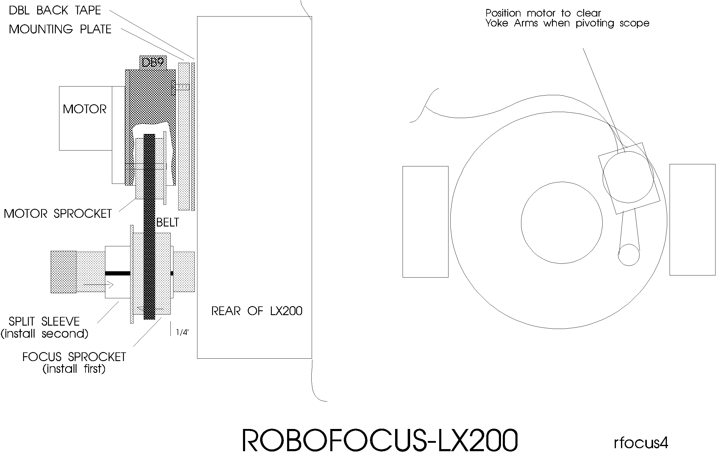

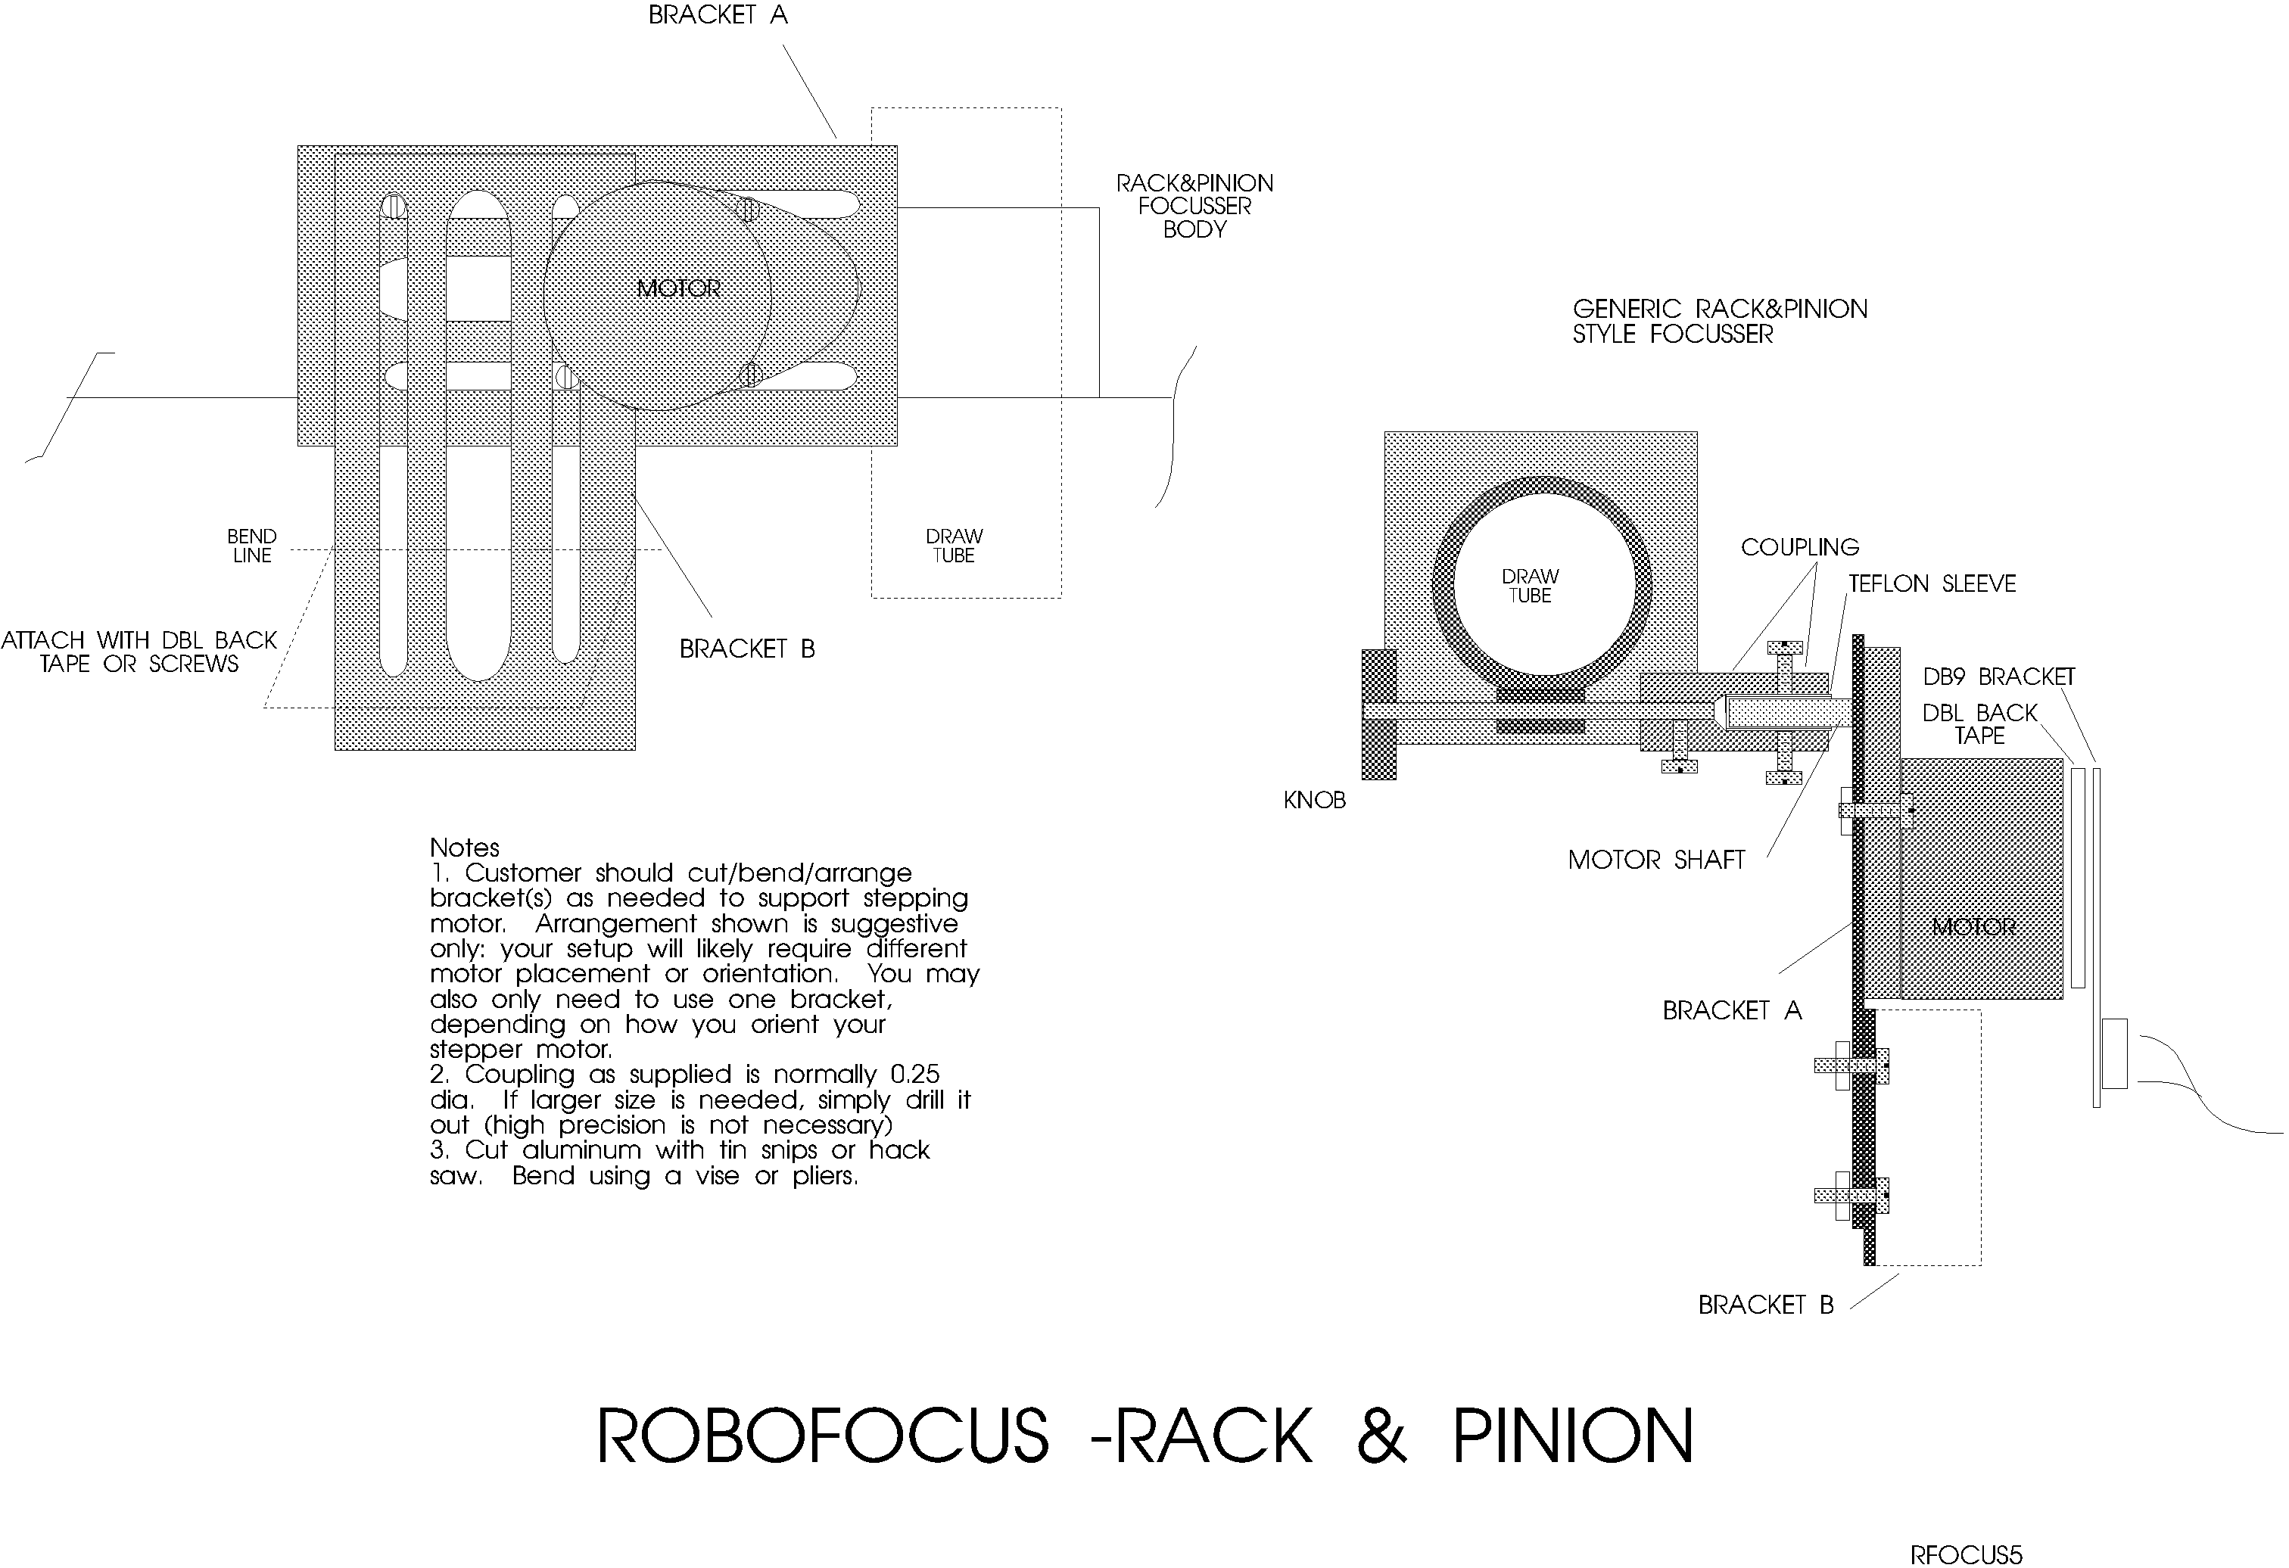

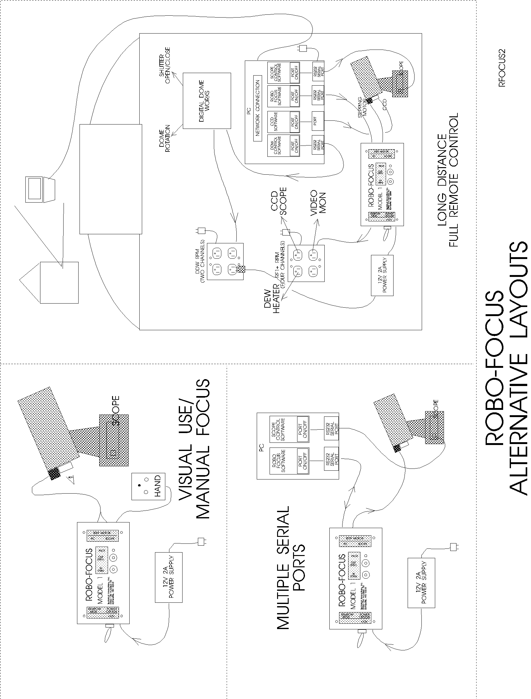

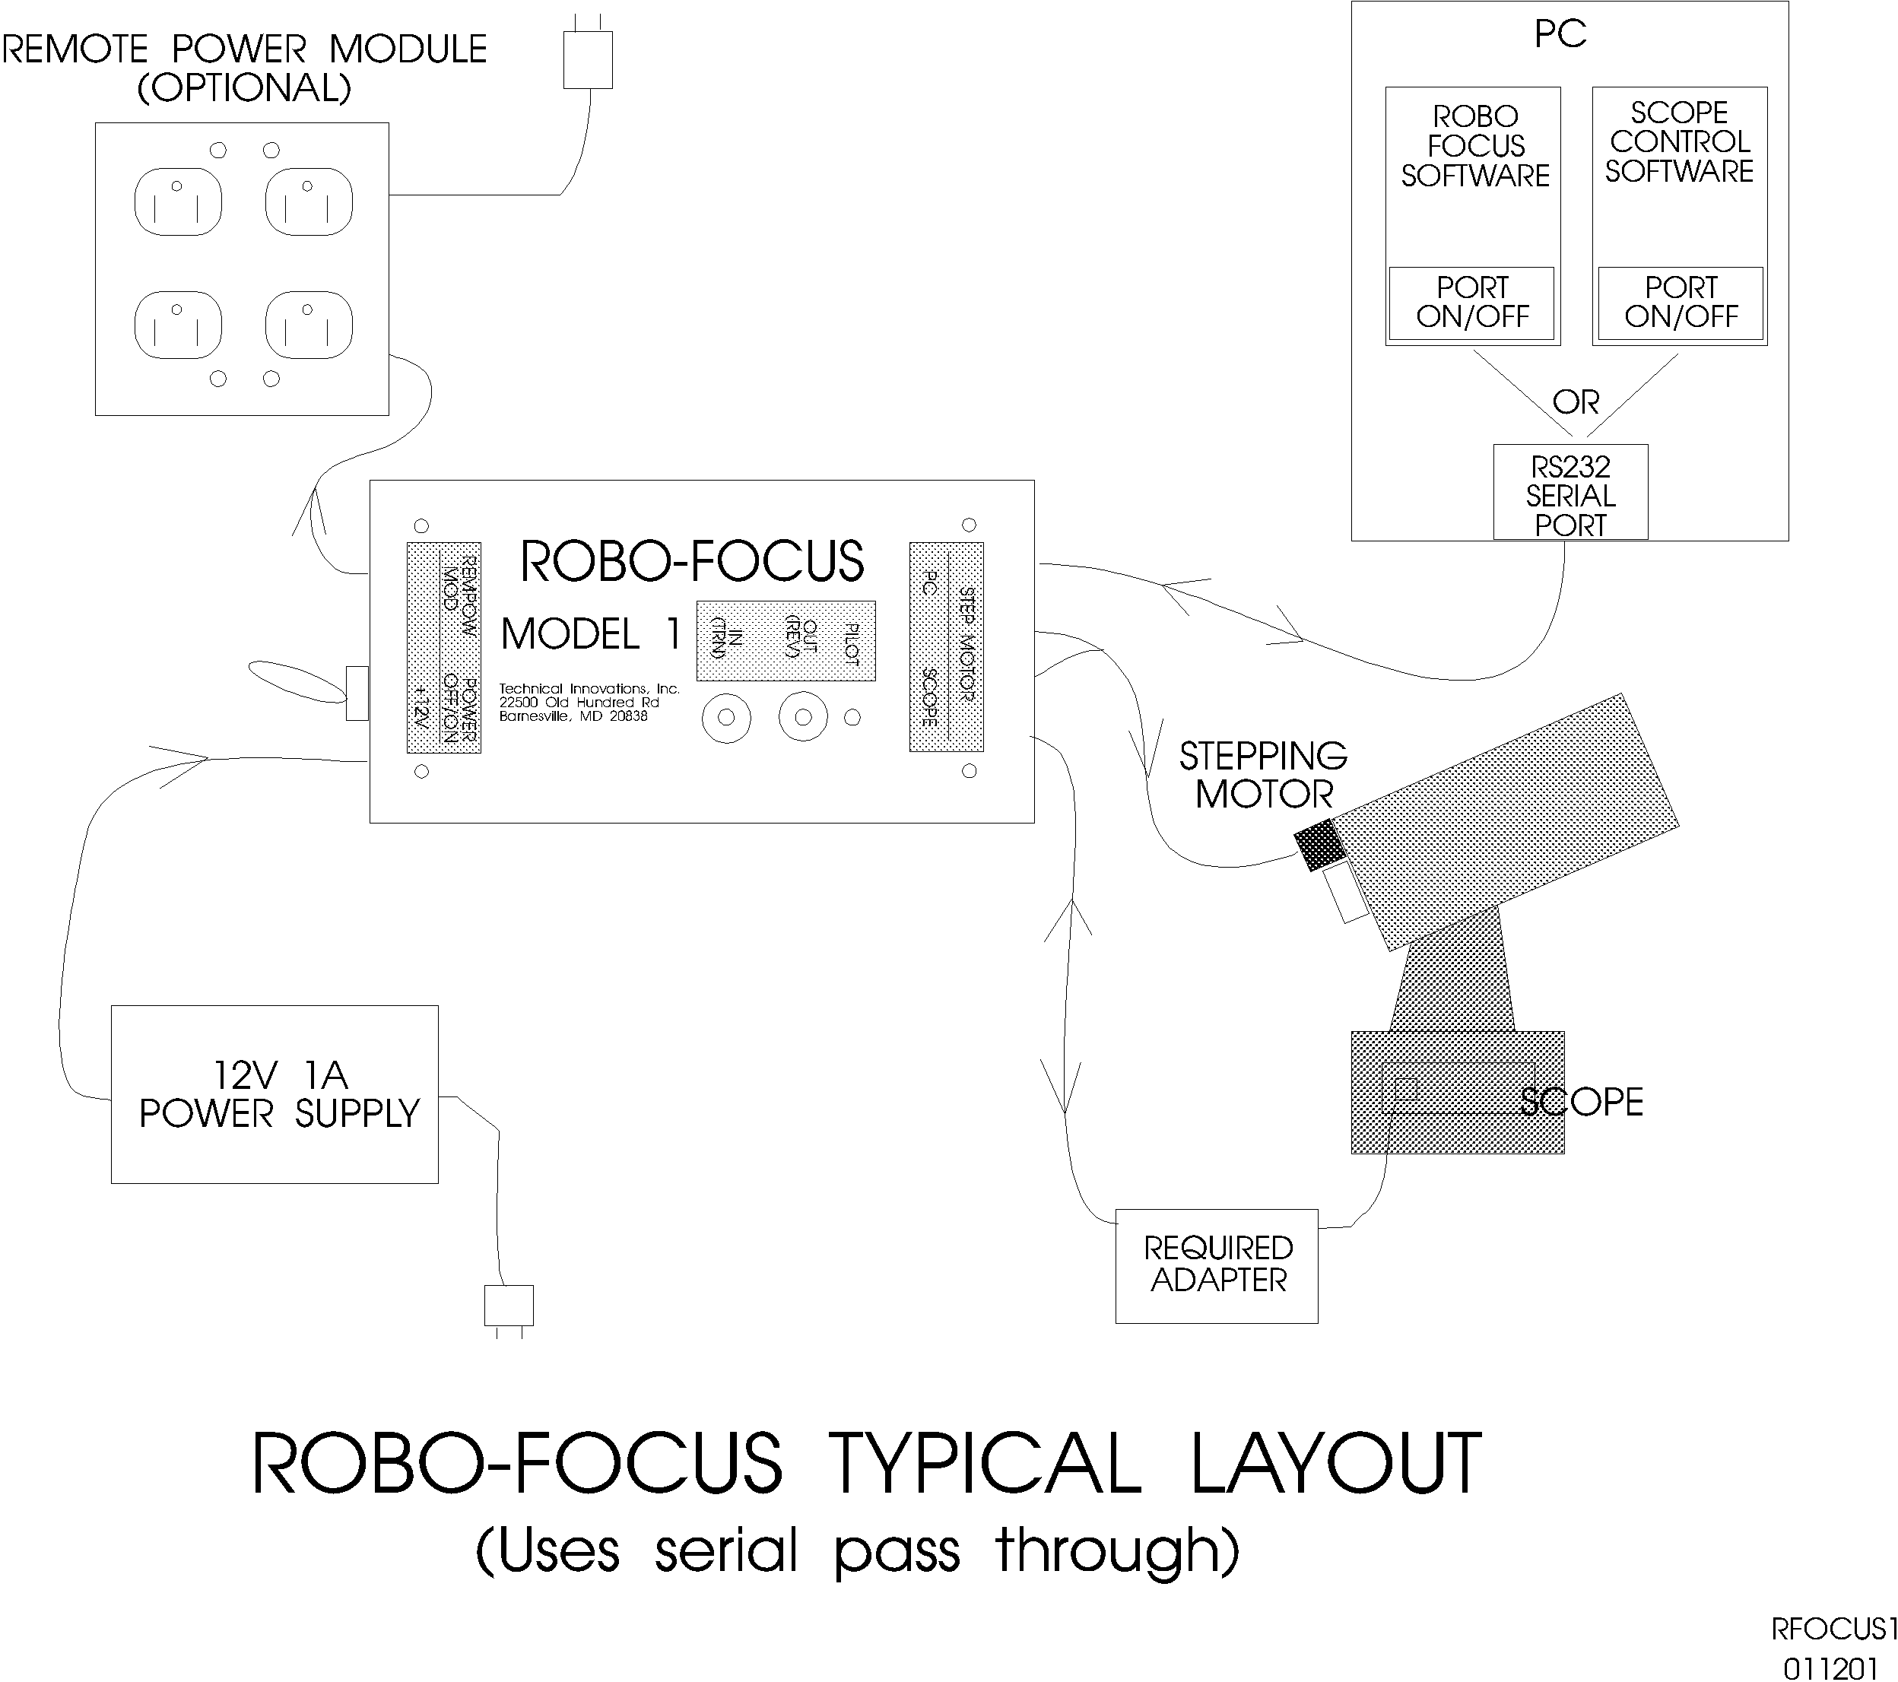

tape, and install the motor base with the timing belt tight. Once installed, you can change the tension by adjusting the mounting screws on the stepper motor bracket. This completes the installation. You will not normally be able to turn the focus knob by hand (even with the RoboFocus turned off) unless you loosen the sprocket set screws.

JMI focuser. JMI makes the NGF focuser which is a Crayford style, zero backlash focuser. The DC motor often used with the focuser can be replaced by a special RoboFocus stepping motor. When installing the new motor, take the focuser off the telescope and be sure to work over a table with a try to catch any small screws or bearings. Installation is as follows (assumes you have a DC motor already mounted):
- Use 3/32 allen wrench to remove the pair of set screws holding the jack shaft and bearing (visible in a slot on the side of the focuser). Working over the tray, turn the focuser on its side and remove the jack shaft and bearing.
- Use 1/16 allen wrench to loosen (don’t remove) the set screw holding the shaft far bearing at the end away from the motor
- Working over the tray, remove the screw holding the motor and remove the motor and shaft from the focuser. An inboard bearing next to the motor will come out with it, and unless you hold it in, the far bearing will likely fall out: Don’t lose it!!
- Install the new motor/shaft with its new inboard bearing. The bearing should fit into its seat in the focuser. Install the motor mounting screw lightly.
- Install the old far bearing onto the new shaft and tighten its set screw
- Drop the jack shaft and bearing into its slot, install the two set screws to equal depths gently tight
- Finish tightening the motor screw.

Installation-RoboFocus Electrical

The RoboFocus has the following connections:
- 120VAC -for the power supply provided.
- 12VDC (positive) input from the power supply
- PC Computer-This is an RS232 connection from the computer. We provide an adapter for the PC jack (PC1) to allow use of 6-conductor telephone cable (we supply a 12ft length). Ideally, the RoboFocus will have its own RS232 serial port on the PC; however, the RoboFocus can also operate on the same port as the telescope control software (see below). See appendix for details on making your own cable: DO NOT USE commercial cables unless you have verified that they are suitable.
- Scope. If you wish to operate the RoboFocus on the same serial port as your telescope, connect the scope to this jack through the proper adapter. See discussion below for details. This jack is also used for the optional RoboFocus hand control (hand control and scope connection cannot be used at the same time). CAUTION: do NOT connect your scope directly to this jack or you may damage it.
- Stepping Motor. The stepping motor connects to the DB9 connector on the RoboFocus unit using the eight foot cable provided.
- Remote Power. The RoboFocus provides four control channels for the user for the optional RoboFocus Remote Power Module. You can remotely power your scope, CCD, dew heaters, etc.

Serial Pass Through

The Scope/Hand jack requires more discussion. As noted, one can connect the RoboFocus to its own serial port (you will need to use the PC1 PC adapter to go from the DB-9 connector on the PC into the telephone type cable used in the RoboFocus).

However, if you are limited in the number of serial ports available, you have a choice of adding serial ports to your PC (see appendix) or you can use the RoboFocus “Scope” jack. The RoboFocus is wired to allow it to be on the same RS232 circuit as other devices, such as the telescope. The signals for both the RoboFocus and the scope pass into the RoboFocus on the same cable. The RoboFocus will respond only to its own signals. The scope signals will pass through the RoboFocus to the scope, and the scope responses will pass back through the RoboFocus to the computer.

Because the wiring of each type of scope is different, you MUST use the proper adapter between the RoboFocus “SCOPE” jack and the scope itself: NEVER connect the scope direct to the RoboFocus controller. If the proper adapter was not included in your RoboFocus package, please call us to obtain one. If you intend to connect to an LX200, and you already have an LX200 adapter that came with a Digital Dome Works system, you can use it.

Unfortunately, your computer will not allow two different programs (e.g., focuser and scope control) to connect to the same serial port at the same time. Therefore, to take full advantage of this feature, the scope and focuser software must be in the same program. Although we expect such software soon, it is not yet available. However, you can take partial advantage of this design and still avoid adding serial ports. To do this, connect your scope (or other RS232 device) to the Scope input, then alternately connect the two software programs to the serial port. For example, you could operate the scope control program to connect the port to the scope, aim the scope at a star, then terminate the scope connection (while leaving the program running). Switch to the focuser control program, open the COM connection, thus connecting the port to the RoboFocus, perform your focusing, then terminate the connection when you are finished. You can then switch back to the scope program for telescope control. These steps are easy to do in Windows. During this process, you have left all wiring in place.

This method will operate with most scopes and software; however, it is possible that some scopes or software will not tolerate the focuser commands and data that are on the same line. Failures will generally show up as software lockup or errors. Because of the coding protections, you will not have inadvertent movements. If you do run into these problems, you will need to use a separate port for the RoboFocus or change software. Our tests with RoboFocus using the same Com port with TheSky and LX200 or the AP GTO scopes show no compatibility problems.

Installation-Remote Power Module

The optional Remote Power Module allows you to control four outlets independently from your computer (or from the RoboFocus itself). If you wish, you can plug multi-outlet strips into the outlets so that you can control more items. Limit the total load to 10A maximum

The Remote Power Module plugs into a wall outlet for its 120VAC supply. Use the six conductor telephone type cable provided to connect the Module to the RoboFocus (do NOT use commercial cables).

Installation-Hand Control

The hand control is an optional two button control that is useful if you do frequent manual focusing (ie., focusing while looking through the eyepiece). The control plugs into the “scope” input. This may require temporary disconnection of the cable from RoboFocus to the scope (this is not a problem as the two functions are not used at the same time). The hand control also has a pilot light that mimics the light on the RoboFocus control unit. All directions given for the control unit push buttons also apply to the hand control.

3. Operation of RoboFocus

Initial Operation

WARNING: Check that you have loosened any focus locks on your focuser! You may want to remove the focus lock so that you don’t accidentally use it in the future.

When you first apply power and turn on your RoboFocus, it has settings for its current position and the length of travel available to it left over from factory testing. Before accurate operation can be done, you will need to train the RoboFocus (you can run RoboFocus without training, but you may not like the various default settings). We suggest that you hook it up and test run the focuser in and out with the buttons. If the focuser is too slow or fast, you may want to change the speed. If the position count is too small or too large as you go from one end of travel to another, you may want to change the number of microsteps per count. You can make these changes either using the manual menu buttons or the computer configuration screen (see below). When the settings are convenient to use, you are ready to Train.

The first training step is to check that the buttons operate the focuser in the correct direction.

Direction Convention. In/Out directions are obvious for a R&P focuser. For a S-C scope, we use CW/CCW for the knob as the corresponding directions. You can operate with reversed directions; however, using the standard avoids confusion.

Direction. To check the RoboFocus direction, push the OUT button. You will notice that when you push the button, the stepper executes one step (with a beep), waits for 1/2 second, then starts running at full speed. This system allows making small focus changes when operating manually. If the RoboFocus OUT button moves the focuser out (CCW on an SC scope), the direction is ok. If the direction is wrong, turn off the RoboFocus. After about ten seconds, turn on the RoboFocus while pressing the OUT button. As the RoboFocus powers up, it will sense the OUT button, will reverse itself (switching from inward to outward), and will record the new button direction. After several seconds the RoboFocus will start running outward and you can release the button. The RoboFocus will remember this direction information for future sessions.

Clutch. You should now check the clutch setting (Rack & Pinion models only). The clutch screws should be set fairly tight, ie., you want to be sure the RoboFocus stepping motor does not slip under any normal operation. The best test is to load the focuser and orient the scope upwards so that the maximum gravitational force is put on the stepping motor. Then operate the IN button while watching for focuser movement. Adjust the clutch screws as necessary to avoid slippage.

Training. You are now ready to train the RoboFocus (you can defer this operation if you wish). To train the RoboFocus, use the OUT button to run the focuser all the way “out” (or at least as close to all the way as you want). Release the OUT button, and turn off the RoboFocus. After ten seconds, turn on the RoboFocus while pressing the IN button. The RoboFocus will read the IN button, will know that it is in the training mode (it will beep five times). The RoboFocus will then wait one second to give you time to let up on the button, after which the focus will begin running in. When the focuser has moved all the way in (or as far as you want it to go which may take several minutes), you may press either button to stop the training run. When the button is pushed, the RoboFocus records its position as =1 and the total focuser travel as the number of steps run, and Training is now complete.

As the RoboFocus moves outward, the position increments by one for each step of the motor. Typically, the full travel for a R&P will be 2-4,000 steps, while the full travel for a S-C may be as many as 100,000 steps. The RoboFocus has a maximum count of 65000. If full travel is needed on a S-C (an unlikely occurrence), you can recalibrate along the way as described below.

Note: you can operate the RoboFocus without training. However, because you have no absolute knowledge of where the focuser is in its travel, you will not know the range of motion available. We recommend training as a first step to assure that at least the approximate length of motion (measured in steps) is known (record this in your log book).

Local Operation.

When you are in the observatory and want to operate the focuser, you may use the RoboFocus buttons to provide local (manual) operation. When using the buttons, you will notice that the stepper steps once (with a beep) and then switches to high speed (this helps in making small focus changes). A few comments:
- If you run all the way in, and then keep going, the stepper will continue to run (with the clutch slipping), and will continue to reset its current position to 1.
- If you run all the way out, and then keep going, the stepper will continue to run, and will continue to reset its current position to a new maximum travel
- If you want to retrain, you can do so at any time. However, the usual problem is that you removed or turned off the RoboFocus and then manually adjusted the focuser. Of course, this causes loss of information on the current position. In this case, although you can retrain, it is often sufficient to simply reset the position to approximately the correct value using your computer (see below).
- If you want to focus with your manual control knob, turn off the RoboFocus. This will release the magnetic brake that prevents motion. If you use manual knob focus you will, of course, lose accurate position data. Focus motion will be stiff, unless you release the clutch screws. Manual button use preserves position data.

Of course, the backlash compensation does not function in local button operation because the user determines the amount of movement.

Remote Operation

For remote operation, activate the Remote Focus Control Program (RFCP) on your PC so that you see the RoboFocus control screen (see below).

The first time you use the RoboFocus, you will need to select the CONFIGuration menu item. Select the COM port and set your communication settings. You will usually be using COM port numbered one through four. The rest of the settings are 9600 baud, 8 bit, 1 stop bit. Note that you can connect/disconnect the COM port without turning the program off/on. The COM port will close when the program is closed. Close the CONFIG screen.

You can now make or break your COM connection from the RFCP by clicking on the Open/Close COM button. When you OPEN the COM port, you automatically issue commands to refresh the RFCP data (version number, current position, and remote power module settings.)

At this point, if you have established communication with the RoboFocus, you will see the current position displayed. The current position updates itself only when you first turn on or when you do a computer directed focus move, or when you click the Refresh box to query the RoboFocus and renew the reading. The RFCP does not poll the RoboFocus controller on a regular basis. This is a typical screen shot in which we see the Digital Dome Works window in the background, and RoboFocus in the foreground with RF control screen above and configuration screen below.

You can operate the focuser in two ways:
- Absolute. Enter the desired position into the position box and hit enter (or double click) and the focuser will move to the desired location.
- Relative. You can enter the desired change in position, then click IN or OUT and the focuser will move accordingly.

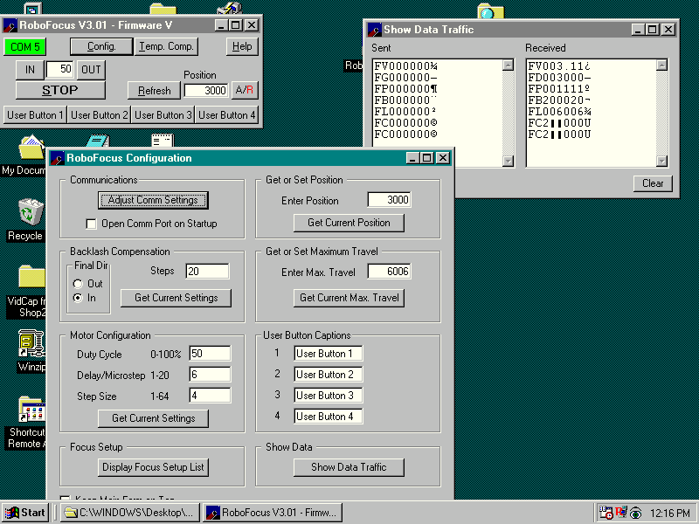

This is a typical screen shot showing the main RoboFocus window (upper left) that controls the system. The larger configuration window (lower left) is also shown. One of the options on the Configuration screen is the ShowData window, shown open on the upper right (this shows the data traffic to and from the roboFocus controller.

In both cases, you will see the position change during movement, then set its final position. If you have a non-zero backlash compensation (configuration screen), this correction will automatically be made.

You can also display the position in two ways by toggling the A/R button next to the position box:
- Absolute. The position box will display the actual count showing the position.
- Relative. The box will show RED signed (+/-) position values relative to when you click the R.

The relative position display is particularly useful for following the net effect of moving focus in or out why focusing (e.g., +2 counts or –12 counts). The display does not change the absolute position count.

You can leave the RFCP running or not, as you wish. Even if RFCP is turned off, if the RoboFocus controller is powered, it will hold the focus setting, as well as any remote control power settings. You may want to leave the RFCP program running, but switch between RoboFocus and a scope program (to avoid software interference) using the COM connect/terminate settings.

Note: Because the RoboFocus requires time to process commands, carry out the instruction, and return data, you should avoid rapid button pushing. That is, give the RoboFocus a few seconds to respond before repeating a command or sending a new one. Also, on some machines with some color settings, running RFCP may change the color of other displays. Please contact us if this causes you a problem.

Configuration and Remote Power Module Operation – Manual Menu.

Although the RoboFocus is designed primarily for computer controlled operation, most of the functions can also be operated manually without a computer (the major exception is that the backlash corrected motions are only available under computer control). Simple IN/OUT movements are made by pushing the IN and OUT pushbuttons. However, as we have already discussed, the pushbuttons also are used for direction reversal and training operation.

In addition, the buttons allow access to the Manual Menu, which allows setting
- Remote Power channels on/off
- Duty cycle of stepping motor when at rest (power consumption)
- Step Rate of motor when running (motor speed)
- Microsteps/count (coarseness of movement)

How do two buttons control all these functions? In general, one starts and then moves through the Manual Menu using the IN button (on the left). The beeper tells you which menu item you are on. At each menu item, the OUT button (on the right) is used to change the setting of the menu item. The power LED tells you what your setting is for the menu item. You leave the Manual Menu using the IN button.

Manual Menu

Menu Item | Name | Description | Beeps
ENTER |  | Push IN and OUT simultaneously gets you to first item. Push IN to move through menu items | 3NR
1 | Remote Power 1 | Push OUT to change state of Remote Power. LED shows whether channel is on or off. | 1R
2 | Remote Power 2 | “ | 2R
3 | Remote Power 3 | “ | 3R
4 | Remote Power 4 | “ | 4R
5 | Stepper Duty | Hold OUT to cycle through the five duty settings. LED shows relative setting (low to high). | 5NR
6 | Stepper Rate | Hold OUT to cycle through the five stepper period settings (short to long). LED shows relative setting. | 6NR
7 | StepSize (Microsteps per step) | Hold OUT to cycle through the five microstep/count settings. LED shows relative setting. | 7NR
EXIT |  | Push IN to exit manual menu. | 8NR
NR=non-repeating beep pattern R=Repeating beep pattern

Remote Power. You can operate the remote power module either locally or remotely.

To operate the remote power module remotely, simply click on the appropriate button in the RFCP. The color will show that the channel is on. Note that you can change the labels on the RoboFocus Control Panel by going into the CONFIG screen. Power Module settings remain in operation until the RoboFocus itself is powered down. That is, if you have a power channel ON, it will remain on even after you turn off the Control Program! It will, however, turn off if you remove power from the RoboFocus. All power channels are off when the RoboFocus powers up. You are responsible for turning off your equipment!

To operate the remote power module locally (i.e., when you are in the observatory without a computer running RFCP), you need to change the status of the RoboFocus into the manual power mode and then select the desired action. You will do this by manipulating the two motion buttons. A beeper will provide audible feedback, while the power indicator lights on the remote power module and the LED on the RoboFocus will tell you whether each channel is off or on. The button commands are:
- Both buttons---Enter manual power mode
- Left (IN) button-----Cycle to each remote power channel
- Right (OUT) button---Change the status of the channel

To enter the manual power mode, hold both buttons down until the RoboFocus begins to beep. Let up on the buttons: you will then hear a single beep every 3-4 seconds showing that you are in Channel 1. If you want to change the state of Channel 1, press the second (OUT) button until you hear multiple beeps, then let it up. The Channel will have changed state, and RoboFocus will again repeat the regular single beep. The RoboFocus LED will tell you whether the power is on or off on that channel. You can change the state of Channel 1 again, if you like. When you are ready to move to Channel 2, hold the left button down until you hear a double beep, then let up. You will now hear a regular two beep cycle. You can change the state of Channel 2, or proceed to Channel 3 or Channel 4 as desired.

Duty. At this point you have cycled through the four remote power channels. If you now press the IN button, you will move to a fifth menu channel (five beeps, not repeated). This channel is used to set the duty cycle of the stepper motor. When the stepper is actually moving, the RoboFocus sends full current to it. However, when the stepper is resting, the RoboFocus can send a smaller current to reduce current drain and heating of the motor. The fraction of current is set by this menu item from 0% on (step1) through five steps to 100% on (step 5). The LED blinking pattern will show the step number. You can change the duty cycle by pressing the OUT button. The new setting will not take effect until you leave the menu (duty settings other than 0 or 100% will usually cause the stepper to “sing”—this is normal. Although five settings of duty are available in the manual menu, you can also set duty to intermediate levels using the computer configuration screen.

Step Period. When you are finished setting the duty, hold the left (IN) button down again. You will hear six beeps, indicating you are in the sixth menu item. The LED will blink 1 to 5 times, showing what your current Step Period setting is (lower numbers are shorter periods and faster stepping action). You can press and hold the OUT button to cycle through the different Step Periods. Note that the factory default is step 2 (about 55 full steps per second) will work with most steppers. Step 1 is about 75/second (too fast for most steppers), while step 5 is about 10 steps per second, a very deliberate pace. Although five settings of the step period are available in the manual menu, you can also set step period to intermediate levels using the computer configuration screen.

StepSize (microsteps per step) setting. When you are finished setting the step period, hold the left (IN) button down again. You will hear seven beeps, indicating you are in the seventh menu item. The LED will blink 1 to 5 times, showing what your current Microstep per count setting is (lower numbers are fewer counts per step). You can press and hold the OUT button to cycle through the different Mircrostep settings. Note that the factory default is step 2 (four microsteps per count which is one full stepper cycle). Although five settings of the Microstep settings are available in the manual menu, you can also set the Microsteps/count to intermediate levels using the computer configuration screen.

When you are finished, press the IN button. After a few seconds, you will hear a series of six additional beeps, indicating that you are out of the manual power control mode. The power LED will again light, showing you are out of the menu. If you continue to hold the button down, the focuser will start to move inward.

After you practice this action a few times, you will find that it will be very easy. If you become a bit confused, simply wait a few seconds for the beeps to tell you what channel you are on. Whenever you want to exit, simply hold down the left button until the beeping has stopped for a second or two (this will cycle through the channels and out of the mode). As with computer commands, wait a few seconds between button pushes—give RoboFocus a chance to tell you what it is doing!

Note: if you do not want to make a change in a menu item, you can just hold the IN button to move right past.

Computer Controlled Operations and Commands

Configuration Settings in RFCP Software

The configuration menu gives you control over a variety of functions and settings by remote control. In all cases, RoboFocus remembers your settings even if the power is removed. Configuration items include the following.

Backlash. Backlash is the “mechanical lag” in the mechanical movement of the focuser itself. That is, depending on the loading of the focuser, and whether you are moving in or out, you after moving in one direction, you may have to move for a substantial distance before actual focus movement begins. To compensate for this, the RoboFocus can operate the commanded distance plus extra steps for compensation, then reverse the extra steps so that all moves no matter what the directions are finished with motion in the same direction. Factory default is compensation set for inbound, 20 steps. This configuration control allows you to turn compensation OFF or to set it to a value of 0-64000 for IN bound (all motions FINISH with movement in the INbound direction) or OUTbound.

The backlash compensation need not be set precisely—all that is needed is to take up the focuser system slack in the direction of concern. Experience shows that 10-20 steps of the RoboFocus are usually enough to accomplish this on a R&P focuser. Depending on the stepper motor used, LX200 may require many hundreds of steps to accomplish the backlash correction.

Get/Set Position. If you enter a Zero in the field (or hit refresh), RoboFocus will respond with the current position. You can always send a position and command the RoboFocus to accept the new position — in effect, you are recalibrating the RoboFocus. This is useful if the RoboFocus loses its position (e.g., because of equipment removal and replacement), but you know approximately where it is. You can also use this command to set a convenient reference point (e.g., 5000) and do not care about losing the absolute calibration that you got from completing the training process. Limit is 64000 steps.

Get/Set Max Travel. You can send a distance (# steps) that you want for the maximum total travel. If you enter a Zero in the field, RoboFocus will respond with its current setting. Usually this setting is derived from training and you would not normally reset this value, but you can if you wish to do so. Assuming you have the Max Travel from your training session, if you are using a R&P focuser, you can divide the measured movement (say 4 inches) by the number of steps (say 2000) to get the distance per step (0.002 inch). Limit is 64000 steps.

Duty Cycle. When the stepper is actually moving, the RoboFocus sends full current to it. However, when the stepper is resting, the RoboFocus can send a smaller current to reduce current drain and heating of the motor. The fraction of current is set by this menu item from 0% to 100% on. The new setting will not take effect until you leave the item. Duty settings other than 0 or 100% will usually cause the stepper to “sing”—this is normal. Duty cycle set through the configuration screen will override the settings done by the manual menu. In any case, the settings are stored in the RoboFocus processor.

Step Period. The RoboFocus processor pauses between its microstep commands. The duration of the pause is the step period in units of 1-20ms. Thus, the longer the step period, the slower the stepper will move. If the step period is set too small, the pulses may be too fast for the stepper to follow and movement will cease or be erratic. A stepper period of about 4 is a good choice. You may want a longer period (slower stepping) if you want to perform diagnostics on the system.

SteepSize (Microsteps/Step). The stepping motor goes through four microsteps before it completes one full electronic/magnetic cycle. One full cycle is small fraction of rotation of the output shaft (depends on the gearing used in the particular motor). The RoboFocus controller counts microsteps internally; however, this configuration item allows you to set the number of microsteps from 1-64 that will be made when you tell the RoboFocus to move one step (count). By changing the microsteps per count setting, you can change the “fineness” of the focus positioning. If you are using a Rack and Pinion where the focus changes very fast as the shaft turns, you would might use 1-10 microsteps per count, while a much slower focus movement on a S-C scope would benefit from 25-100 microsteps per count. With a count maximum of 64,000, a larger microsteps/count also allows a longer travel without resetting the position count. If you find that you need a finer focus adjustment, simply reduce the number of microsteps per count.

Show Data.

The Show Data button brings up a separate screen that shows the serial communication out to the RoboFocus and back to the PC. This is useful in diagnosing problems in the system.

Focus Setup

The Focus Setup button brings up a screen in which you can record the name or description of up to 20 different optical setups, and for each one identify the “correct” focus. Thus, if you change optical setups, or use the RoboFocus control program for more than one scope, you can easily run the focuser to the desired position (and then refine the focus, if needed).

Temperature Compensation

This button brings up the temperature compensation function of RoboFocus. Because many scopes shift focus with temperature, it is desirable to be able automatically to adjust the focus as the temperature changes during the observing session. Temperature is sensed using a sensor in the RoboFocus control box, or by a separate sensor that attaches to the telescope. Preparing for using the temperature compensation requires that the user “train” the temperature compensation by determining the way the focus changes for each optical setup as the temperature changes and saving the training results. To use the temperature compensation system, the user opens the training file for the particular optical setup then starts the temperature compensation system.
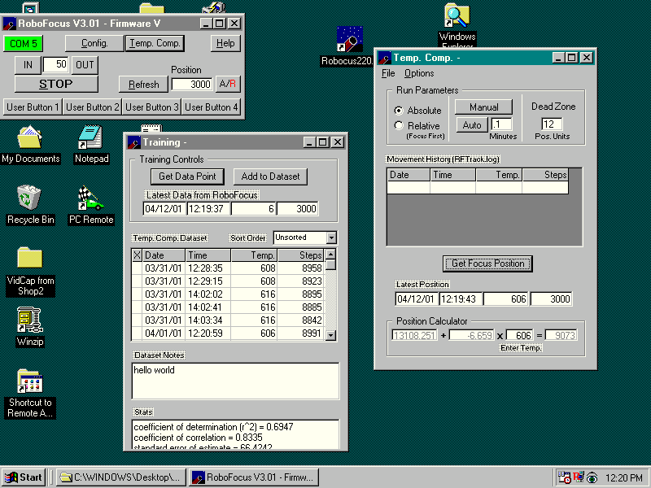

Note: temperature is measured using the built in temperature sensor in the RoboFocus controller, or by a separate temperature probe that one attaches to the telescope itself. The temperature readings are in “counts” (the counts are close to twice the absolute temperature in deg. Kelvin, with 32F=0C=273K=546 counts approximately). Thus, one temperature count is roughly one degree F. We do expect to provide a temperature calibration/conversion in a later version of this program.

We have supplied a temperature compensation dataset that was taken with an 8in. f/10 LX200 under test conditions. Your setup will almost surely have different values for all the data; however, it will give you some idea of how the data might look. As noted below, you can inspect the file using RFCP, Notepad, or Excel. Except to experiment, do NOT use this file to operate your telescope as it will surely produce incorrect results.

Training. The basic idea of training is to gather data on how the focus of the telescope changes as temperature changes. Thus, you want to train during an evening (or more than one evening) when the temperature is either likely to change, or is at least at a different temperature from that experienced in previous training sessions. You would normally want at least focus measurements at at least three substantially different temperatures, and with at least a half dozen focus position measurements at each temperature. Training can extend over several sessions of using the same optical setup (lenses, cameras, Barlows, etc). A typical training process would be as follows:
- Using the temp comp menu, open the training window.
- If you have previously trained using the current optical setup, open the relevant file. When you open a file, the RFCP will take the stepsize (microstep per step) setting used in the earlier training and send it to the RoboFocus controller so that the new data will fit the old.
- Focus the telescope
- Click on the GetData button. This will send a command to the RoboFocus unit to get the current temperature and focus position which are put into the new data boxes. If you like the new data and want to add it to the dataset click the “add to dataset” button. You can have up to 600 focus:temperature measurements in each data set.
- You can click on this or any other piece of the data which will move the data into the editing box where you can edit the data, replace the old entry in the data set, or delete it.
- You may reorganize the data by date/time, temperature, or position.
- If you want to do wholesale editing of data, combine data sets, or perform other complex editing, you can go to Explorer, find the data file, then use Notepad to edit, cut, paste, etc.
- You may enter an “X” into the left hand column on the data set if you wish to leave the data piece in the data set, but EXCLUDE it from the temperature compensation calculation.
- Each time you enter or edit a piece of data, the system automatically recomputes the best calculated fit for the focus vs. temperature relationship. The coefficients in this equation are displayed in the “position calculator” in the main temp comp window. Correlation coefficients and expected error given the spread in the data) are displayed in a window at the bottom of the window (you can rezize the window to make this go away).
- You should save the data set at convenient times during the training session.
- You may inspect the data set in several different ways. Obviously, you can look at the data points in the RFCP table, or use Notepad. Or you can open a spreadsheet (e.g., Excel), and then select and open the data file. Excel will present a wizard which parses the data into proper columns. You can then select the temperature and position columns, and create an X-Y graph that will show the data graphically.
- You can enter short notes in the “dataset notes” box to describe the data set

Caution: if your current focus position calibration is different from earlier training sessions, you will introduce major errors into your data set. If this is the case, before you train, you should recalibrate the focuser to match the data set so that the new data will fit. To do so
- Focus the telescope
- Take a data piece “GetData”
- The temperature reading will automatically be entered into the formula box and the program will compute the best fit position using the data already in the dataset. Recalibrate RoboFocus to that position by entering that position into the RoboFocus/Configuration/CurrentPosition box. You can now take additional data and add them to the dataset.

Temperature Compensation Operation. You can use your training data set in several ways automatically to keep your scope in focus during an observation session. Here is how to do it:
- Use FILE to Open the data set you wish to use. When the file opens, the program will use data in the file to insert the last used values of DeadZone and AutoRate (see below), and will reset the stepsize (microsteps/step) setting to that used in the data set. Failure to have the proper stepsize or changing it during a run will cause incorrect temperature compensation; therefor the temperature compensation software will check the stepsize before it takes a reading and reset the stepsize if necessary.
- Select Absolute or Relative. Absolute means that the RoboFocus will compute the proper focus position from the data set and will send the focus to that position. However, your current position calibration may be different from that used when you took the training data. You could recalibrate. However, the other option is to use the Relative option to make all the compensation changes relative to the current calibration. To do this FIRST focus the telescope, THEN click on Relative. Once activated, the control program will now shift the focus as the temperature changes (using the slope data from the training data set).
- If you select Relative, the main RF window will switch to relative, so that the cumulative movement is easy to see as +/- red numbers.
- Select the Dead Zone. This is the minimum amount of movement that must be computed before the focus correction is actually applied. The purpose here is to set the DeadZone small enough that necessary focus changes will be made, but large enough so that unnecessary focus movements will be avoided. Note that each time a focus correction is done during an exposure, if there is a backlash correction it is likely that the image will go out of focus for a second or so.
- Select when/how often the temperature compensation is to be done. You can operate manually anytime by pressing the MANUAL button whenever you want a temperature measurement and correction (if necessary) made. Alternatively, you can select AUTO and set the frequency of automatic temperature measurement and correction to be made. Most people will select a rate of about one correction per minute (the correction will not actually be made unless the calculated motion exceeds the dead zone).
- The FIRST time a reading is made in Manual or Auto the result before correction is written into the session record. The commanded correction is then written into the session record as the second entry. Thus, the first entry always tells you the starting point of the session.
- Each time a temperature measurement is made, it will be entered into the “latest data” boxes on the screen. The temperature will be also be automatically entered into the compensation formula, which will compute the best fit position using the data set. Finally, if a movement correction is actually made, the data will be added to the session record in the window.
- When operating temperature compensation, changes to the dataset are locked out.
- A log is made automatically of each operating session. Measurements that result in focus motions are written to the file RFTRACK.LOG (use Explorer to find it, usually in the same folder as the program). Up to 1000 items in a session are allowed. The file is a simple ASCII file which can be inspected, renamed, or moved into a spreadsheet or graph as described above. Any old file is converted to RFTrackOld when you open the temperature compensation window (and the preexisting RFTrackOld is erased).
- You can Clear the session record at any time using the Clear item on the file menu. Session data will still remain in the log.

Note: when you close the temperature compensation option the temperature compensation operation will cease. Normally you will want to minimize the window during your observation session.

Possible Problems in running temperature compensation. The key to proper temperature compensation is to have a reasonable data set. Under most applications, the dataset does not have to be of very high quality; however, it must span a reasonable amount of temperature change covering or near your operating temperature.

Most operating problems arise from using a data set taken under one set of optical conditions and applying them to another setup. In general, any change in your setup that changes the f/ratio will change the correction coefficient. While the software will force the operating stepsize to the correct value (matching the dataset), it cannot compensate automatically for changes in the position calibration (that is why using the Relative mode is so useful).

A more subtle error can be that you might have reversed the sense of the motion after you took the dataset. If you look at the position calculator formula, you will see the form A+B*(temp)=Position. B is the slope, ie., the number of steps per temperature count that the scope focus will change. You may have taken the data with one direction (giving for example -6.6 slope), but if you change the RF reference direction, the -6.97 will be in the wrong direction. If that occurs, you could develop a new dataset (which will show about +6.97) but the easier solution is to reverse the RF direction setting using the manual buttons (see ch.3 setup instructions).

As noted above, the standard temperature sensor is mounted inside the controller. In most cases, this is sufficiently accurate; however, you may wish to use a separate optional sensor on the scope itself.

Help/About

The Help button on the control screen brings up a copy of this manual. This is a WORD file which you may read or print out. The About button shows the version of the RoboFocus control program.

ASCOM and Scripting

The RoboFocus control program is available with full ASCOM scripting interface. We are unable to provide training or examples in scripting; however, ASCOM can be pursued via the WEB (simply search on ASCOM). We fully expect that very soon customers will be using this facility and sharing it with other users. Please contact us for details.

Focusing Strategies

There are as many focusing strategies (almost) as there are astronomers. Regardless of the method you use, the RoboFocus allows you to return to the same setting, and to make small, known changes to your focus. In the near future, software will control a CCD camera and the RoboFocus to provide automatic focusing! Meanwhile, however, let us describe briefly several of the methods people use.

In general, if you are imaging planets or other extended objects, you will normally focus on a nearby star, then move to the object to be imaged, knowing that the focus is correct. This process is much faster than trying to focus the scope on the extended object, especially if poor atmospheric seeing causes the image to be distorted differently in successive images.

Visual. Many users will find that the RoboFocus allows them manually to control the focus while avoiding touching the telescope (which induces vibration). In this case, the eye provides the indication of focus. Using the dual rate focusing, you can make the tiniest corrections to focus settings. If you do much visual focusing, you may want to use the Manual Menu to slow the stepping (longer step periods).

Photographic. When using film, the focusing is normally done with a single lens reflex or other camera with a ground glass screen. Once the focus is determined, the RoboFocus allows the user to return to that position using the computer control.

CCD Camera. The CCD camera and software provide several different methods of focusing. Usually, focusing is best done by taking successive images of a medium bright star. The CCD software then provides several measures of the quality of the stellar image. An easy measure to use is the peak brightness (one adjusts focus for maximum brightness). Another measure is the Full Width Half Maximum (a measure of the image width in pixels, which one focusses to minimize).

Many astronomers employ a variety of devices (usually masks with holes or wires) that fit onto the front of the scope. These introduce image artifacts that one observes when adjusting focus. An obvious problem with these devices is that they are difficult to employ in a remote operation. However, the good news is that most users find that the peak or FWHM methods work as well or better.

Schmidt-Cassegrain Scopes. We also note that many scopes (especially Schmidt-Cassegrain) shift focus with movement around the sky and with temperature changes. The solution is to check and correct the focus on a nearby star whenever you suspect a change may have occurred. If you record your RoboFocus settings in your log, you may find that you can easily keep your focus setting extremely accurate. The RoboFocus incorporates spare circuitry that will allow the later addition of a thermal compensation scheme when that is available.

Some astronomers use the manual focus knob on a S-C to set “coarse” focus, then use one of the zero backlash focusers for fine focusing. On the other hand, many users find that RoboFocus on the manual knob gives sufficiently accurate results. However, some may want to continue to use the manual focus for coarse focus, then use a RoboFocus equipped high quality focuser for the fine focusing. This is feasible, and does allow the user to lock the S-C mirror, thus minimizing mirror flop during operation.

Changing Setups. What is the best way to handle a new optical setup? For example, you might install a Barlow or a Reducer that you know will greatly change the focus. If you have already used the setup, you would probably have recorded the RoboFocus position for each setup either using your log book or using the FocusSetup menu item. Thus, if at position 5643 for setup 1, when you go to setup2 you might simply command a move to 12523 (outward 6880 steps) to get very close to the correct focus. This move might take several minutes. You would then tweak the focus using your CCD imager.

On the other hand, if you are changing to a new setup that you have not used before, how do you find focus without doing dozens of slow tests? One way is to put in an eyepiece that you know has about the same focus point as the camera. You would then use the manual buttons to move to approximate focus, and then refine with the camera.

You can also do it easily without visual work. You would direct the scope to a reasonably bright star, and set the CCD to take quick pictures (e.g., 0.1 sec, bin 3). You will see a huge out-of –focus star image, or maybe only a piece of one (or maybe even just the “hole” in an out of focus S-C star image!). You could repeatedly move the RoboFocus a hundred steps and reshoot, but that will be slow. A better way is to direct the RoboFocus to begin a large move (say from present 5624 to 25,000). You then take repeated images (continuously) while the focuser is moving. As you approach focus, the image will improve as you watch, and you can stop the RoboFocus as you pass through focus. You would then refine the focus in the usual way. Once you have the focus position for the new setup, you would record it for future use.

In any case, once you are close to focus, you can usually achieve "perfect" focus in only a few minutes by taking several images and comparing peak or FWHM readings. No matter how you use RoboFocus, once you have a good focus position, you should record it in your log. In fact, most users will have several optical setups (e.g., with and without a Barlow), so you may have several different values recorded.

When using RoboFocus, you may want to redefine the current position (in the Configuration screen) to a more convenient value (such as 1000). Of course, unless you keep a record, you will lose the absolute position determined from training; however, the ease of referring to round numbers often outweighs this factor.

Multiple Setups. You can use Configuration/Setups to record the information about a setup. This might include which lenses are in use (e.g., reducer), filters, or other things that might affect the focus position. If you use the same controller that you attach to different motors, each setup (including configuration items) can be described in this mini-log.

Some users will have several RoboFocus controllers (each with its own motor) that they want to control from a single computer. You might have each controller attached to its own port. In that case, you could run one copy of RFCP and switch the COM port as desired to run each motor in succession. The minilog would then include the relevant comport number of that controller. On the other hand, you might want to run several copies of the RFCP at the same time, each set to its own comport. Again, the minilog would help you keep straight which program is controlling which motor.

Problems

Loss of position. The most common reasons that accurate position is lost are:
- Manual disconnect and operation. If the stepping motor is disconnected (or powered off) and the focuser manually changed, the RoboFocus position will be in error
- Overtravel and sticking reverse. The stepping motor can be driven to one end and then continued as the clutch slips. This will not result in error. However, if the stepping motor is now reversed, if the focuser shaft is binding or stuck, the clutch will again slip, but the stepper thinks it is moving.
- Focus Creep. If the power is removed from the RoboFocus with the scope in an orientation that allows gravity to move the focuser in or out, focus may drift, thus introducing an error in the position. If the duty cycle is set too low, the stepper may also allow the focuser to drift.

In each case, the RoboFocus must be recalibrated. You may be able to do this remotely (using the configuration Screen) by getting back to a focus condition whose position you know, and recalibrating on that. If you need to know the absolute focus position, you can only do this by on site training.

Stepping Motor Heating. The stepping motor will operate almost hot to the touch in normal operation at 100% duty. If you wish to reduce the temperature (or reduce current demand), you can reduce the duty cycle using the manual menu or the PC configuration screen described above.

Temperature Compensation Problems. See the discussion above under temperature compensation.

Appendix 1 Software Commands

Although not discussed above, the processor includes coding to allow one or both ends of the focuser travel to incorporate end of travel interlocks (closure to ground). The customer would provide this to fit each installation. No special software settings are required.

All RFCP commands are sent/received to the RoboFocus in standard RS232 at 9600 baud, 8 bit, no parity. Commands must be sent as a block within approximately 400 ms (ie., if sending manually, the typing must be fast). All commands and data received are of form “FXNNNNNNZ” where
- “F” denotes focuser command
- “X” is a alpha character denoting which command
- “?” is an arbitrary character as a placeholder
- “NNNNNN” are six decimal digits with leading zeros as necessary
- “Z” is a checksum character of value 0-255. Its value is the result of adding all the previous characters together and setting Z equal to the least significant byte.

All data sets are nine ASCI characters (e.g., the character of value 48 represents a “0”). There is no end of command character. If subsequent characters are sent to the RoboFocus(such as a CR), they may be interpreted by RoboFocus as a stop command (see below).

When a command is received, RoboFocus computes the checksum for the received characters. If it does not match, or if there are illegal characters, the command is ignored. After a valid command or pushbutton that causes motion, the RoboFocus responds with movement ticks (about 10-50 per second) which is a string of the character “I” or “O”. When motion ceases, RoboFocus issues a final packet of form “FXNNNNNNZ”. X corresponds to the command that was sent. If a command is sent during a movement, the command will cause the motion to cease. In general, if it is a legal command, it will still be accepted and then will be executed.

The RoboFocus processor has limited built-in data checking. Where a 65K limit exists, RoboFocus controller does not block the command but will roll over its count for that parameter. In general, external control software should have all necessary limits and format requirements built in.

Note that the standard motor we provide is rated as a "0.1 deg/step" unit (3600 “steps” per revolution of the geared down output shaft). When the motor companies rate the number of steps, they are really counting the "microsteps" of the rotor. One complete cycle of the motor rotor (a “whole step”) itself takes four microsteps. In our V2 firmware, we make output shaft movements in whole steps, ie., four microsteps. Therefor, our standard motor will rotate one complete turn in 900 of the "steps" from the RoboFocus. In our V3 firmware (with temp comp), the user can select the stepsize, ie., the number of microsteps per “step”.

FVXXXXXXZ. Commands RoboFocus to respond with RoboFocus firmware version number. Response is FVXXXXXXZ.

FG?XXXXXZ. Commands RoboFocus to goto position ?XXXXX. If ?XXXXX are all zeros, response from the RoboFocus is the current position in the form FD?XXXXXZ. If ?XXXXX represents non-zero, the RoboFocus will take this as the target position and begin moving. As the stepper moves, RoboFocus responds to the command with the character “I” or “O” for each step. At the conclusion of the move, RoboFocus sends the current position FD?XXXXXZ. Note actual limit is 65K (there is a spare digit for the future).

FI?XXXXXZ. Commands RoboFocus to move inward by ?XXXXX steps then sends current position. Note actual limit is 65K (one digit is spare).

FO?XXXXXZ. Commands RoboFocus to move outward by ?XXXXX steps then sends current position. Note actual limit is 65K (one digit is spare).

FS?XXXXXZ. Commands RoboFocus to set current position to ?XXXXX. If ?XXXXX=0 then RoboFocus responds with the current position. If ?XXXXX<>0, RoboFocus responds with new current position. Note limit is 64000 (there is a spare digit for the future).

FL?XXXXXZ Commands RoboFocus to set maximum travel to ?XXXXX. If ?XXXXX=0 then RoboFocus responds with the old setting. If ?XXXXX<>0, RoboFocus responds with the new setting. Form of response is FL?XXXXXZ. Note there is a limit of 65K (there is a spare digit for the future).

FP??XXXXZ Commands RoboFocus to set the four outputs for the remote power module. The channels are 1-4 L-R.. If ??XXXX=0 then RoboFocus responds with the current power settings. If X=1 the channel will be set to OFF; if an X=2, the channel will be set to ON. Values other than 0-2 are interpreted as 0. RoboFocus responds with the new power settings in form FP??XXXXZ.

FBNXXXXXZ. Commands RoboFocus to change form of backlash compensation. If XXXX=0 then RoboFocus responds with the current settings. N=1 is no compensation (N=1 not supported in V3 or later firmware), N=2 is compensation added to IN motion, N=3 is compensation added to OUT motion. XXXXX is amount of compensation as 1-255. Factory default is 200020 (IN with 20 steps). RoboFocus response is FBNXXXXXZ.

Any command. During movement, RoboFocus monitors its input serial channel. Any serial activity is taken as an immediate stop command and movement will cease (if the buttons on the RoboFocus are pushed during computer driven movement it will also stop). RoboFocus response will be the current position. Note that if the same serial port is being used simultaneously for the telescope control using an integrated program, the scope control software may interrogate the scope during a focus movement, which will stop the focus movement.

FCABCDEFZ. Commands RoboFocus to set configuration. If ABCDE=0 then RoboFocus responds with current configuration settings. If non-zero, configurations be set as follows:
A-spare
B-spare
C-spare
D-Duty Cycle. This character has an ASCI value of 0-250 which corresponds to a duty cycle for the stepper of 0-100%.
E-Step Delay. This character has an allowed ASCI value of 1-64 approximately equal to the time delay in ms per microstep of the stepper.
F-Step Size. This character has an allowed ASCI value of 1-64 equal to the number of microsteps needed to produce one “step” of the focus position. High numbers are coarse steps.

FTXXXXXXZ. Commands RoboFocus to take temperature reading and respond. Response is FTXXNNNNZ where NNNN is the temperature reading in raw counts 0-1024 from the ten bit ADC. The count is normally within 1% of 2X the Kelvin temperature (Count of 600 equals 300K equals 27C).

Appendix 2 Schematic Diagram

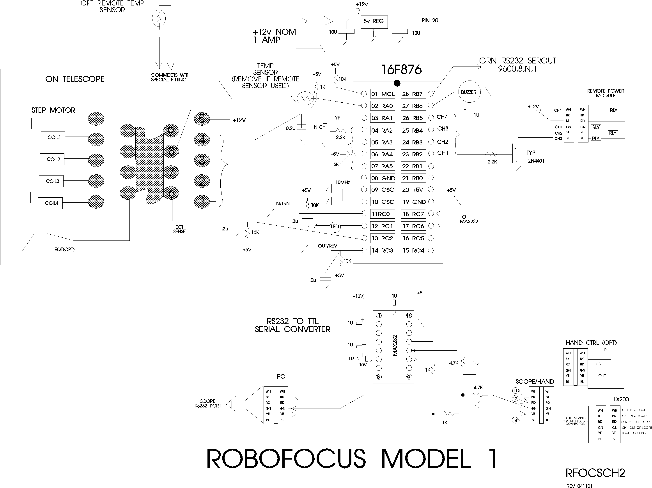

RoboFocus Stepper Colors

DB9 | HURST(standard) | NIPPON PF
1 coil A | BLK | YEL
2 coil A | WHI | ORG
3 coil B | BLU | BLK
4 coil B | RED | BRN
5 common | BLK/WHI-BLU/WHI | RED-RED

Nippon Motor connections for flat telephone cable

NIPPON PF | RJ11 6 | CABLE | DB9M TO RJ11 ADAPT  RJ11 COLOR—DB9MALE
BLK | GRN | GRN | RED—3
BRN | YEL | YEL | BLK—4
RED-RED | RED | RED | GRN—5
ORG | BLU | BLU | WHI—2
YEL | WHI | WHI | BLU--1

Appendix 3 Serial Cables

DO NOT use commercial telephone cables and extensions. In telephone service, the practice is to flip the wires from end to end. Thus, if you connect multiple cables together, you will not preserve which wire is carrying which signal. You can check this by holding the two ends of a cable next to each other, oriented the same way (thumb tab down). If you see that the colors are reversed, you cannot use that cable. You can, however, make your own correct cable if you like (or get them from us).

Although most of these wires are provided as precut 6-conductor telephone type flat cables (with RJ11 modular plugs), you may want to cut and install plugs on your own telephone cables. Measure the length needed, and trim the ends clean. You will need a good quality crimper (available from us or from an electronics supplier such as Radio Shack).

To install a RJ11 connector, follow these steps:
• Provide good light! If you cannot easily see the smallest details of this task, you will make mistakes and will not be aware of them. A little extra care in making the connections saves hours of troubleshooting later!
• Use sharp diagonal cutters to trim the end of the cable squarely. You must not have any metal wire strands sticking out the end.
• Place the cable into the stripping portion of the crimp tool (this has an upper and lower knife to cut the insulation.
• Pull the cable away, thus stripping about 5/16 in. of the OUTER insulation (the insulation on each wire should remain).
• Orient the cable in your left hand with the black/white conductors toward the right (Depending on the cable type, the black may be second from the right). Orient the connector so that the finger latch is DOWN (underneath). Insert the cable end into the connector until the wires bump the end inside (this is important because some conductors may in time work their way out of their insulation--leaving space at the end of the conductor may then allow them to short together).
• Insert the connector with wire into the crimp portion of the tool. Squeeze the handle and check that the six crimp bars are pressing on the crimp conductors of the connector. Complete the crimp, squeezing hard and firm.
• Remove the connector. Using a magnifier if necessary, inspect the connector closely and check that all six of the crimp conductors were pressed down, and that the wire orientation (black to the right with thumb key underneath) is correct.

Note: the wire orientation in the connector is absolutely critical. Contrary to telephone service, the orientation of wiring in this system must be maintained. This is so a signal will always travel on the same color wire through the various connectors and cables.

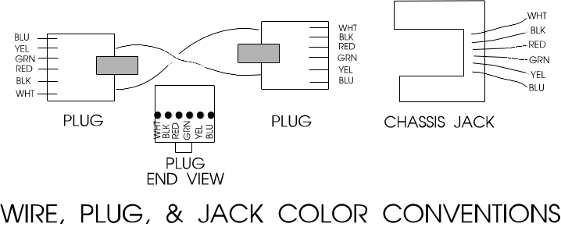If the connector is not right in any way, simply cut it off and apply another one. It is virtually impossible to verify that a particular connector is good or bad: If a cable is suspected as bad, cut off both ends and install new connectors. If this does not solve the problem, make a new cable.

Appendix 4 Serial Ports and Cables

Introduction

In the following discussion, we use DEVICE to stand for either Digital Dome Works, Dome Wizard, RoboFocus or other device as may be appropriate to your installation.

The communication between the computer and the DEVICE is via a "serial" cable connected to a PC serial port, called a COMmunications Port (for purposes of this discussion RS232 and “serial” refer to the same thing). If the settings for the software do not match the port, communication will not succeed. In this section, we'll talk about COM ports.

A standard PC running a recent version of Windows (or alternative operating system) frequently has three serial ports numbered COM1-COM3, which are often assigned to:
• mouse (usually COM1)
• spare(COM2)
• modem (usually on COM3 in our port assignments)

Some PCs have a separate special input for the Mouse (PS/2 style), which frees the COM1 port for other uses.

A remote control observatory may require that the control computer have enough serial ports to serve:
• mouse
• modem (optional)
• telescope
• CCD (may be a parallel port rather than serial)
• DEVICE

Task: You will need to assure that your computer has the correct number of RS232 ports to serve your needs, and you will need to have the proper cables to run from your computer to the observatory. In this appendix, we will discuss both issues.

Serial Cable Options

Regardless of how many conductors the long cable has, we only use three for the serial communication (e.g., black, green, and yellow on 6-conductor cable).

We provide nominal 10-ft. signal cables to connect your PC to DEVICE. This will work fine if your computer is in or next to the dome. However, if you need to run longer cables, you can order them from us or easily build and install your own. For relatively short runs (roughly up to 50-75 feet), you can use standard six conductor flat telephone cable with standard six conductor connectors.

If you are at a substantial distance, say, 100 ft or more. you may need to run the cable in some type of conduit underground, and you may want cable that is physically stronger. The cable for the RS232 can be almost any reasonably low capacitance, three (or more) conductor cable, for example, twisted shielded pair. For long runs, use reasonably large wire (e.g., 20 gauge conductors). We have used a variety of wire types, including “thermostat” wire (4 conductor) and even Romex #14 building wire (2 wires plus ground).

The easiest and most flexible way to make the connections is to use a standard 6 conductor telephone jack (female) with wire leads. You can then simply hook the proper wire color to each of your long wire conductors, and then use our standard (or your own) phone cables for inside the dome and control room. The colors we use are Black (ground, DB9-5), Yellow (PC in DB9-3), and Green (PC out DB9-2). You can also use various other types of connectors (e.g. DB9, use numbers above plus jumper DB9-7 and 8). See the schematic of connectors in the rear of this instruction manual for further details.

Parallel Cable Options

As noted, some CCD cameras require parallel cables. Standard lengths are 10-25 feet. However, you can make or purchase cables up to 100 or more feet long; however, they do get quite expensive. If you are putting the cable in conduit, you may not be able to get the connector through the conduit. Thus, you can’t easily install the connectors ahead of time, test the cable, and then install it. This can make system checkout more difficult. Consult with your CCD supplier for more information. Note that if your control room is far away from the observatory (more than 100 ft.), you will probably find it useful to install a computer in the dome, and run the system as “Long distance Remote” using a local network. This may save money, and is a more flexible system.

Multiple Serial Ports

As noted above, you may need to provide more serial ports in your computer. Many inexpensive "multi-port" cards are available to add ports, and most of these cards are supported by modern Windows versions. However, the most inexpensive cards may require an IRQ for each port which your computer may not have available.

Since mid-2000, several new devices have come to market. There are now internal cards that provide 4 or more serial ports that do NOT use IRQs. You can find these by searching on the Internet. Costs will be in the $125-250 range. A second development is the wider use of USB ports. Again, in recent months USB devices that offer four or more serial ports have become available, also in the $125-250 price range. With these developments, adding serial ports to non-laptops is much easier. Most of the rest of this appendix describes concerns for older port expansion electronics.

If a computer is included in the DEVICE package, t already has the necessary cards installed and configured. If you are using your own computer and need additional serial ports, you will need to add a new card to your PC (many laptops will support additional ports via PCMCIA cards).

The programs that control each observatory component include a method of selecting a COM port. For example, in DEVICE, it is done in the Configure. Check the instruction manual for your telescope and CCD software to find how to set the COM/parallel port setting for those devices.

Proper operation requires that each component be connected to the physical port that has been assigned in its software. Failure to plug into the correct, assigned port will result in a "failure to connect" or some similar error message. If the connection is not successful, you will receive a message to that effect.:

USB

Although we have no plans to implement a USB port on the Digital Dome Works hardware, some USB to Serial converters have appeared which provide standard RS-232 serial ports and connect to the computer by USB port. These devices come with driver software that makes the serial converter appear to software as a standard COM port. Several converters may be operated in parallel via a USB Hub to gain multiple serial (and/or parallel) ports. These converters are often restricted to use with Windows 95/98 (not NT), so the user must determine if a given converter is suitable. Some software, expecting to communicate directly to a serial or parallel port’s hardware, may not be able to exploit a USB converter- this is dependent upon the software itself. We have tested communications from Digital Dome Works and TheSKY via an USB to Serial converter and found both to work fine under Windows 98. Extensive reliability testing under different mixes of hardware, tasks and multitasking has not been done, so we are not aware of the possible problems a user may face.

The user should also be aware that the USB standard is in a state of evolution, and it is possible a substantial investment in USB hardware could become useless if standards evolve unfavorably with respect to particular combinations of hardware, software and operating system. We don’t expect this is likely, but since USB and related standards are so new, support them is subject to future decisions of the companies involved.

Serial Port Expansion Cards

Modern PCs are supplied with two serial ports; one is a 9-pin male and the other a 25-pin female. Typically they are designated as COM1 and COM2 respectively. If a mouse is supplied, it is connected in one of the following ways; directly into the 9 pin serial connector, into its own “PS/2” style jack, into the 25 pin connector via a 9 pin to 25 pin adapter, or into its own specialized card input jack. Assuming the mouse is hooked either to COM1 or COM2, only one COM port is free for accessories. There is a market for USB devices, which in principal can offer functions in this area. USB is a serial bus standard, which allows multiple devices (mice, keyboards, and joysticks) to be connected to a single wire. However, since the USB market is small, proprietary and expensive, we do not intend to support it in the foreseeable future, so it will not be discussed here.

Depending upon the devices attached to the PC, you will have particular needs with respect to I/O ports. First, the Observatory controller requires 1 COM port- our standard port is COM2, although all our software will support COM1 through COM9. CCD cameras typically use a LPT (printer) port, but some require a serial port and others require both. The Telescope mount will consume either another COM port or an LPT port depending upon the particular mount design.

Modems can either use an existing port, or can supply one of their own- depending upon the modem’s design. Internal modems always supply their own, often as COM3 so as not to conflict with COM1 and COM2 as supplied by the main system board. External modems always need a 9 or 25 pin COM port, thereby using one supplied by the main system board or expansion card.

If your system only requires 1 LPT port for the CCD, 1 COM port for the Observatory and 1 COM port for the Telescope mount, it may be possible to set the system up without requiring additional COM/LPT port cards. The key is to use an internal modem (if you need a modem) and ensure your computer main board accepts a PS/2 style mouse (most motherboards less than 2 years old do). If your motherboard supports PS/2 mice, it might be just a matter of purchasing a PS/2 style mouse, plugging it in and enabling PS/2 mouse functions via main system board jumpers or CMOS settings. Windows 3.1 and up will directly recognize PS/2 mice (as will alternative operating systems like Linux or BeOS). If your main system board does not support PS/2 mice, or you don’t have a sufficient quantity of COM and LPT ports, you will most likely need an expansion card.

There are many variations of COM/LPT expansion cards, offering a wide array of port combinations, data rate capabilities and connector styles. Costs will range from $10 for old style cards pulled from XT/AT machines to several hundred dollars for the latest, most capable versions. In our experience, cards which mix 2 or more COM ports plus 1 or more LPT ports are the most effective in this application. (Don’t ignore the XT/AT pulls out of hand, they could do exactly what you need. If you buy one, be sure you know how to configure it!) We purchase cards in the $40 to $150 price range, from Jameco Electronics (www.jameco.com) and JDR (www.jdr.com). We select cards which provide additional 9 pin and 25 pin ports, or those with a large cable connector from which dangle individual, short cables with 9 pin and 25 pin connectors. The particular UART chips employed on the card are of little concern in this application and can be ignored unless you have special requirements. If you search around, you may run into the 4 or more port serial boards, costing in the many hundreds to thousands of dollars. These cards are very capable and are specially designed to not “overconsume” system resources as discussed below. Unless your needs are stringent or you’ve exhausted other avenues, leave these fancy cards as a final alternative. Although most of the COM/LPT expansion cards will be “ISA” bus, you will some PCI bus cards. The ads/salespeople will claim they are “faster”- certainly they are more expensive, but consider the limiting factor in the communications link is the device sending the data. PCI Vs ISA offer little or no performance difference with respect to speed with which Telescopes or DEVICE transmit on COM/LPT ports. On the other hand, if you are servicing an ISDN modem, a high throughput card is preferred.

Our experience is, the most important factor in selecting a card is the configurability. Specifically, each COM and LPT port on a card will utilize one of a limited number of IRQ “slots” on the main system board. Many other PC functions also use them, typically leaving only several available for expansion card use. Consequently, it is often the case that on a fancy, new multi port card there are one or more of the ports which are useless because of a lack of IRQ slots. In the scenario, some operating systems other than Windows have the advantage because many can “share” IRQ slots among serial ports, thereby allowing you to more flexibly configure the computer. Windows is certainly obsolete in this area. If you are not conversant with adding cards to PCs and dealing with IRQ/IO port address setting with the consequent software configuration adjustments, there are a variety of do-it-yourself books on the subject. Almost any store selling PC s or PC hardware will be willing to install one for you (for a sometimes substantial cost). If you do give your computer to someone to work on, be SURE to back up any important or irreplaceable data/software first!

Windows 95 and up will support COM ports greater than 4. Usually all that is necessary is to add the New Hardware, and supply the correct IRQ and I/O address values. However, we have had mixed experience coaxing Windows 95 to properly accept new ports contributed by older multi-port serial cards. If you are forced to use Windows, you may end up being forced into purchasing more expensive, specialized cards to overcome this recalcitrance. While offering very good performance, these cards will easily cost an additional $150 or more. Our preferred brand is DigiBoard; this firm offers a 4 port ISA card for approximately $250, which is the cheapest we were able to find. On the other hand, it might be a large time savings to use one of these boards, as it could considerably simplify your hardware configuration.

Be sure to closely examine any available information regarding the card before you purchase. Try to ensure you can choose from at least 6 different IRQ settings and at least 6 I/O address, or I/O port settings. These 2 parameters indicate how flexibly you can configure the card to “work around” other cards/hardware installed in your system. Unfortunately, the cost of the card is somewhat proportional to its “configurability”. The particular IRQ and I/O settings offered by these cards are surprisingly standard. Once you reach the 6 IRQ and 6 I/O address threshold you can consider the card quite flexible. If the card doesn’t offer that level of configurability, and you still want it, you should be sure you understand how you will use the configuration options it offers.

The following is a somewhat extreme example of what one may go through while trying to add serial ports to a PC. If you aren’t confident you can work through problems such as this, please consult a PC technician or call us.

Assume you need 1 more COM and 1 more LPT port. You find a card which offers 4 serial ports each configurable for COM1 through COM5 (IRQ 2,3,5,7,9) and one LPT port configurable from LPT1 to LPT3 (IRQ 5,7) for the LPT port. You already have COM1, COM2 and LPT1 from the main system board and COM3 from an internal modem. Your mouse is PS/2. Your choices are somewhat limited, but by leaving a couple serial ports “useless”, you can almost do what you need. From examining your Modem settings you find your modem uses IRQ 5. COM1 and COM2, by tradition, occupy IRQ 3 and 4. Thus you have only IRQ 7 and 9 available for COM5. LPT1, supplied by your main board, uses IRQ 7. Note, this board won’t let you use IRQ numbers over 9, which is limiting your assignment of COM port IRQs. A more configurable card selection would allow the use of IRQs like 10,11,12, and 15. You could assign IRQ9 to COM5, and IRQ7 to LPT2. First, you must find out if any other hardware is already using IRQ9. Soundcards, SCSI cards, and LAN boards are likely candidates. If IRQ9 is already in use, you are faced with a hardware reconfiguration job to free it up, which could be impossible- or you must find an alternative expansion card. For the LPT port, we can’t use IRQ5 because the modem needs it, so we must use IRQ 7 instead. We note it is already assigned to LPT1, but since IRQ lines are infrequently used on printer ports (unlike COM ports which require them) we will cross our fingers and hope there are no software conflicts. Now, even if everything works, you still have 3 unusable COM ports on your new card because of the lack of IRQ configurability. Consequently, this card is rather a poor choice since you can’t get it properly set up- hence the importance of closely examining both your PC s configuration and the prospective expansion card.

Serial Communications Troubleshooting

If you have difficulty getting the PC and DEVICE to communicate, there are several areas to investigate. The suggestions below start with the easiest first.

System Verification. One of the first steps is to verify that the basic equipment is working. If you have a COM port that works (for example, one that currently serves the telescope), you may temporarily connect the DEVICE (with PC-SBC adapter) to that port. Set the DEVICE Com port to the same setting that you were using for the port (e.g., in the telescope control software). If you now establish connection, you will prove that the control program and the device are both operating correctly, the cables are good, and that the problem is in configuring or identifying the proper COM port.

If you still do not connect, you may have a bad cable or connector. Try substituting another cable or adapter and retry the connection.

User of Double Female Device. We can supply a double female adapter that accepts a telephone type connector on each end. The device includes two small LED lamps wired onto our GRN and YEL wires. When connected into the serial line to the DEVICE, these lamps will normally show GRN. (I.e. both the PC and the DEVICE are listening). Each lamp will blink RED when a transmission occurs. Thus, if a normal command is sent (such as GET INFO), one lamp will flicker RED for about a tenth of a second (look sharp—it’s quick!). Normally, in less than a second, DEVICE will respond and the second lamp will flicker RED showing transmission back to the PC. Using these indicators, you can determine where and in what direction the communication failure is occurring. In conditions of high ambient light it may be difficult to see the red flicker indicating communication- so please look carefully.

If you are unable to produce a usable COM port for the DEVICE, you may require assistance either to change internal settings in the computer (as discussed above) or to install internal cards in the PC to provide additional COM ports as discussed above. Please feel free to call us for help.

Appendix 5 ASCOM Scripting

The RoboFocus Control Program exposes an ActiveX interface and can be invoked with syntax similar to this VBScript example:

Set myRF = CreateObject("RoboFocus.FocusControl")
msgbox myRF.actOpenComm()
msgbox "Comm port status: " & myRF.getCommStatus()
msgBox "Firmware version: " & myRF.getFirmwareVersion()
myRF.actCloseComm()

This code starts an instance of the RoboFocus Control Program, opens the comm port, displays the comm port status, and queries the device for the firmware version and displays it, then closes the comm port.

Below is a list of all the functions exposed by the RoboFocus Control Program for use by client software. For a VBScript example of each function call, see RoboFocusExample.vbs, which is included on the CD.

Functions that Return Settings:

getFirmwareVersion() As String
Returns the firmware version if connected, or the string “Not Connected” if not.

getPosition() As Integer
Returns the current position of RoboFocus if connected, or –1 if not.

getDelta() As Integer
Returns the current delta value (the amount that a click on “In” or “Out” will move RoboFocus. Returns –1 if not connected.

getUserButtonState(ByVal Button As Integer) As Boolean
Takes a button number from 1 through 4, and returns the current state of the button, True for on and False for off.

getUserButtonCaption(ByVal Button As Integer) As String
Takes a button number from 1 through 4, and returns the current caption of that button.

getCommStatus() As Boolean
Returns the current status of the comm port specified in the RoboFocus Configuration screen, true if connected, and False if not.

getOpenCommPortOnStartup() As Boolean
Returns the state of the “Open Comm Port on Startup” checkbox on the Configuration screen, true if checked and False if not.

getBacklashDirection() As Integer
Returns the value of the Backlash Direction radio buttons on the Configuration screen. Off = 1, In = 2, and Out = 3. Returns –1 if not connected.

getBacklashSteps() As Integer
Returns the value of the BacklashSteps field on the Configuration screen, or returns –1 if not connected.

getMaxTravel() As Integer
Returns the value of the Maximum Travel field on the Configuration screen, or returns –1 if not connected.

getKeepMainOnTop() As Boolean
Returns the state of the “Keep Main Form on Top” checkbox on the Configuration screen, True if checked and False if not.

getDataTraffic(ByVal Direction As Integer) As String
Takes an integer indicating which data stream to return, 1 for data that has been sent to roboFocus and 2 for received data. Returns a string containing up to 1000 characters.

getCmdActive() as Boolean
Returns true if a command is currently being processed by the hardware, and false if not.

getTempCompAbsRel() As Integer
Returns 0 if Temperature Compensation is in absolute mode, 1 if in relative mode, -1 if not connected or no dataset open.

getAutoRate() As Single
Returns the value in the Auto Rate field, or -1 if no dataset loaded.

getDeadZone() As Integer
Returns the value in the Dead Zone field, or -1 if no dataset loaded.

Functions that Alter Settings:

setPosition(ByVal position As Long) As Long
Takes a position in Long format. Valid values are 0 through 65535. Sets the current position of RoboFocus to the passed value. Returns the position after the action is complete, or –1 if RoboFocus is offline. If the command was successful, the current position returned will equal the passed value.

setDelta(ByVal Delta As Long) As Long
Takes a delta value in Long format. Valid values are 0 through 65535. Sets delta to the passed value. Returns the delta value after the action is complete, or –1 if RoboFocus is offline. If the command was successful, the current delta returned will equal the passed value.

setUserButtonCaption(ByVal Button As Integer, ByVal Caption As String) As String
Takes an integer button number from 1 through 4, and a caption string. Sets the caption of the specified button to the string. Returns the caption after the action is complete. If the command was successful, the returned caption will equal the passed string.

setOpenCommPortOnStartup(ByVal OpenPort As Boolean) As Boolean
Takes a boolean value and sets the “Open Comm Port on Startup” checkbox accordingly. Returns the setting of the checkbox after the action is complete. If the command was successful, the returned value will equal the passed value.

setBacklashDirection(ByVal Dir As Integer) As Integer
Takes an integer direction, 1 for No Backlash, 2 for In, and 3 for Out. Sets the Backlash Direction to the specified direction, and returns the direction value after the action is complete, or –1 if RoboFocus is offline. If the command was successful, the returned value will equal the passed value.

setBacklashSteps(ByVal backlashSteps As Long) As Long
Takes a Steps value in Long format. Valid values are 0 through 65535. Sets Backlash Steps to the passed value, and returns the Steps value after the action is complete, or –1 if RoboFocus is offline. If the command was successful, the returned value will equal the passed value.

setMaxTravel(ByVal maxTravel As Long) As Long
Takes a value for Maximum Travel in Long format. Valid values are 0 through 65535. Sets Maximum Travel to the passed value, and returns the Maximum Travel value after the action is complete, or –1 if RoboFocus is offline. If the command was successful, the returned value will equal the passed value.

setKeepMainOnTop(ByVal KeepMainOnTop As Boolean) As Boolean
Takes a boolean value and sets the “Keep Main Form on Top” checkbox accordingly. Returns the setting of the checkbox after the action is complete. If the command was successful, the returned value will equal the passed value.

setTempCompAbsRel(ByVal absRel As Integer) As Integer
If absRel = 0, absolute mode will be selected. AbsRel = 1 selects relative mode. The resulting mode is returned as a 0 or 1. If no dataset has been loaded, or the comm port is not open, no change results, and a –1 is returned.

setAutoRate(ByVal autoRate As Single) As Single
Sets the contents of the Auto Rate field, and returns the passed Auto Rate Interval if successful. Returns a -1 if no dataset is loaded.

setDeadZone(ByVal deadZone As Integer) As Integer
Sets the contents of the Dead Zone field, and returns the passed Dead Zone if successful. Returns a -1 if no dataset is loaded.

Functions that Perform an Action:

actGoToPosition(ByVal position As Long) As Boolean
Takes a position value between 1 and 65535, and moves RoboFocus to that position. Returns True if RoboFocus is online, or False if not. Equivalent to entering a number in the “Position” field and pressing enter.

actStop() As Boolean
Sends a Stop command to RoboFocus. Returns True if RoboFocus is online, or False if not. Equivalent to clicking the “Stop” button.

actIn() As Boolean
Commands RoboFocus to go In the amount of ticks specified in the Delta field. Returns True if RoboFocus is online, or False if not. Equivalent to clicking the “In” button.

actOut() As Boolean
Commands RoboFocus to go Out the amount of ticks specified in the Delta field. Returns True if RoboFocus is online, or False if not. Equivalent to clicking the “Out” button.

actRefresh() As Boolean
Queries the RoboFocus hardware for its current settings. Returns True if RoboFocus is online, or False if not. Equivalent to clicking the “Refresh” button.

actUserButtonToggle(ByVal Button As Integer) As Boolean
Takes an integer value from 1 through 4 and toggles the specified User Button. Returns the User Button state after the action is completed.

actOpenComm() As Boolean
Opens the Comm Port (if it’s currently closed.) Returns the status of the comm port after the action is completed.

actCloseComm() As Boolean
Closes the Comm Port (if it’s currently open.) Returns the status of the comm port after the action is completed.

actTempCompManual() As Boolean
Performs a click on the Manual Button, and returns true if click worked, or false if offline or no dataset.

actTempCompAuto() As Boolean
Performs a click on the Auto Button, and returns true if successful, or false if offline or no dataset.

actLoadTempCompFile(ByVal TCFile As String) As Boolean
TCFile is the path and name of a valid TCD (Temperature Compensation Data) file. The file is opened and the coefficients are calculated. Returns true if the file loaded successfully, false if not.

Appendix 6 Parts List

PART | DESCRIPTION | #
RoboFocus Unit | Module with processor | 1
Power Supply | 12V 0.8A positive w 5.5/2.1 plug | 1
Instructions | Manual | 1
Compact disc | CD with RoboFocus Control Program | 1
Stepper Cable | 9 conductor with M/F DB9, eight feet | 1
Connection Cables | PC-RoboFocus 6-cond cable 12 ft. | 1
PC1 adapter | Converts DB9 on PC to telephone cable | 1
Stepping Motor Assembly | R&P: Motor w/plug&plate, clutch coupling w/ allen wrench, two brackets, double-back tape (8”), hardware: 6-32x1/2”PH + nuts(8@)  ----- OR -----  S-C: Motor/sprocket on bracket w/double-back tape, sprocket & bushing, belt (LX200 standard/Celestron optional)  -------OR--------  JMI: Motor with extended shaft and inboard ball bearing to install in place of JMI DC motor, 1/16 and 3/32 allen wrenches, 6-32x3/8 screw | 1
 | OPTIONS
Hand Control | Two button hand control with LED  Connection cable 6 cond 12 ft | 1  1
Remote Power Module | Provides four channels for 120VAC power control, w/12ft 6cond cable, 6 ft power cable | 1 set
LX200 Scope Adapter | 3 jack adapter, w/ two 6-cond.cables (six inch length, 12 ft length). Provides proper adapter for serial feed-through to LX200 (accommodates hand control if used). | 1 set
AP GTO Scope Adapter | (Accommodates pass-through plus hand control.)  3 jack adapter, w/ two 6-cond.cables (six inch length, 12 ft length)and PC-1M to provide proper adapter for serial feed-through to LX200 | 1 set
Other Scope Adapter | Please inquire about adapters for other scope mounts
PC1 adapter | Converts DB9 at PC to 6-cond telephone cable | 1
6-Conductor Cable | Custom length, on request | 1

Appendix 7 Ins Manual Revisions

Date | Revision
111000 | Add ASCOM appendix
112800 | Add colors and pins to schematic
010201 | Update Sch for hand ctrl
010401 | Add getCmdActive() to Appendix 5
011201 | Serial pass through warnings, drawing changes
021201 | Add LX200 adapter, cables, to parts list as option
040101 | Version 3 software and firmware, temp comp, convert double s’s to singles

Ddw/robofocusins3.doc

